How to Crop Safely and Save in Photoshop
Step One:
Download your photo to your download folder from email or google drive
Step Two:
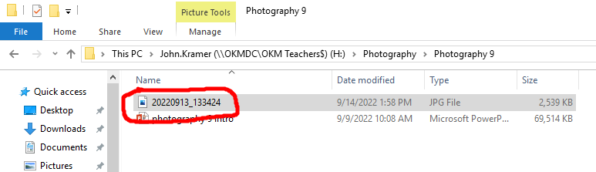
Save your image to your Photography 9 Folder in your H drive:

Step Three:
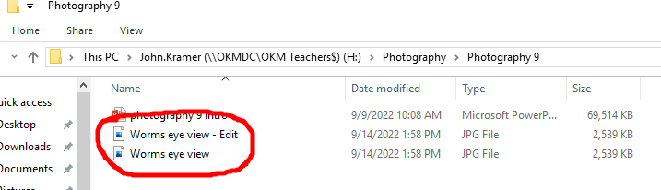
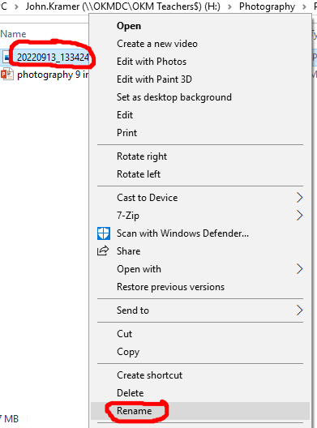
Rename the file by right clicking on it and selecting rename (left picture) and make an edit copy (right picture):

Step Four:
Open the edit image up in photoshop (We will leave the original untouched in case we make an error and need to go back and fix it):
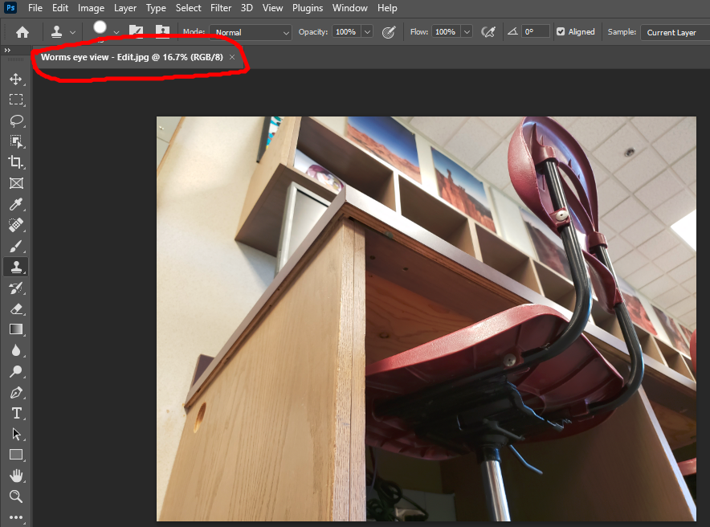

Step Five:
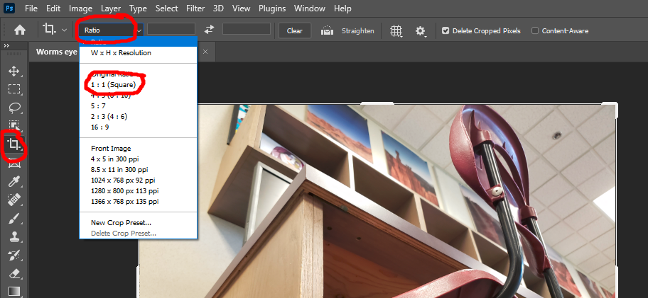
Select the crop tool button on the toolbar to the left. Next select the Ratio drop down on the toolbar above the stage. Finally select the 1:1 cropping ratio as shown below:
Step Six:
Crop your photo making sure to frame the elements so that your subject is the main focus. Using the rule of thirds grid that is shown with the crop tool can help as seen below:
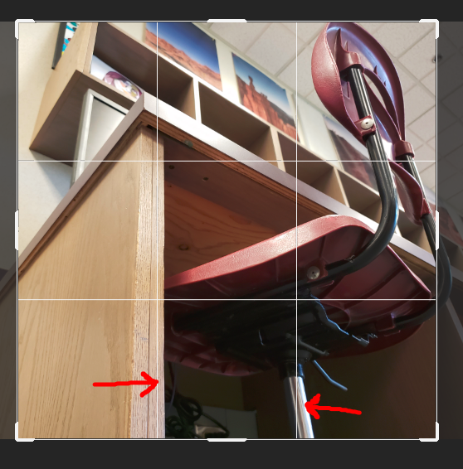
(Note how the rule of thirds grid lines up with the edge of the desk, AND the chair leg)

Step Seven:
When you are satisfied with the edit to your photo, press enter on the keyboard and this will set your transformation. At this point you are welcome to try using some of the adjustment tools in the adjustment tool bar to see what they do. I well walk you through the editing process in the future but this will give you a chance to experiment.
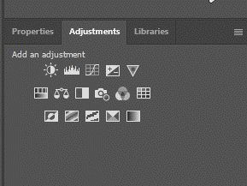
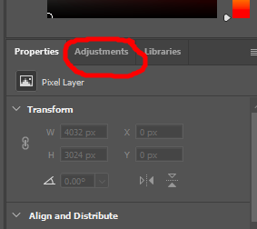

Step Eight:
It is now time to save your work. You will save a photoshop file and a jpg of your work. To do this, select the file drop down menu and "save as":
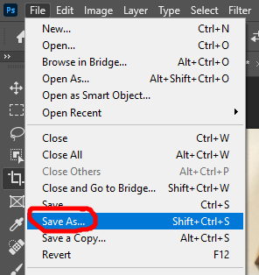

Step Nine:
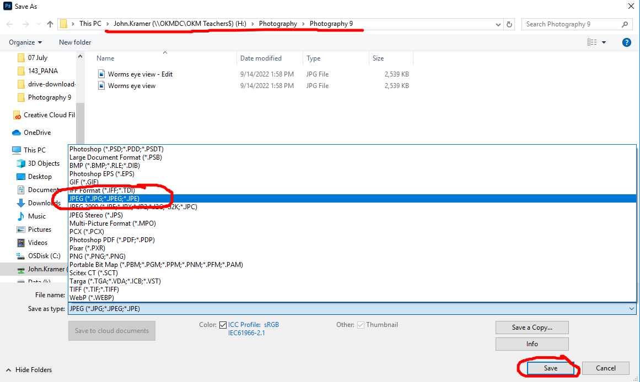
Select the file of type, and save it to the same folder that your originals are in with the same name as a jpeg. You will get a warning that the file exists do you want to replace? Select Yes:

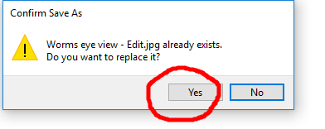

Step Ten:
Save the file as a photoshop file. You will use the same process as before but you will select photoshop file instead of jpeg. You are saving this file so that you can go back to the editing stage again if you need to, all of your settings are saved.
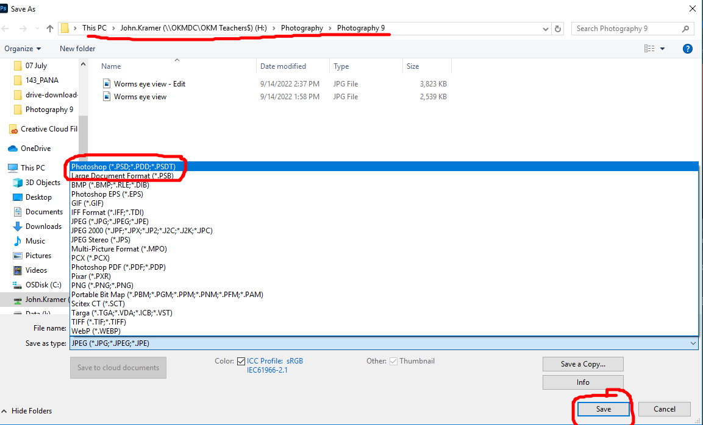

That is it! Every time you bring in a picture for editing, follow the same process and you will not lose any data from your files. Next lesson we will start to create a filing system so that we can find our files quickly and easily.

Next steps: After editing all of your images as shown above, upload them to your weebly site, arrange them nicely, add titles (ie: worms eye view, shoulder view etc.) Add the exif data for each image (Camera model, focal length, shutter speed, F-Stop, and ISO).

