Microsoft Excel Assignment #2
Part A
In this assignment, we are going to set up a spreadsheet that will automatically calculate prices of goods for a company, the tax (GST, PST and HST), the price total, and re-calculated price for discounted goods (for a 20% off sale).
To set up the spreadsheet, you must first come up with a business name, and a list of 30 goods that you may sell as seen in the following screen shot, and the categories across the top.
Once you have the sheet set up in this manner, you will have to enter prices for each item. Do this by hand, selecting appropriate prices for each item.
Once you have the fields filled, then use the appropriate formulas to fill the columns for Discount, GST, PST, HST and Total. Ensure that the total only includes the price and the HST (12%). Also, for the Total with discount, use the Discount price and the HST to calculate that total.
Eg. Formula: =B7*0.2 (this would calculate 20% of the value in cell B7).
Part B

Now that you have completed that part of the form, you need to open a new sheet within this workbook that is filled with data. You can choose the subject that the data represents (cupcakes produced per week, per year for example) and enter the values.

You must have 30 rows and 10 columns worth of data.
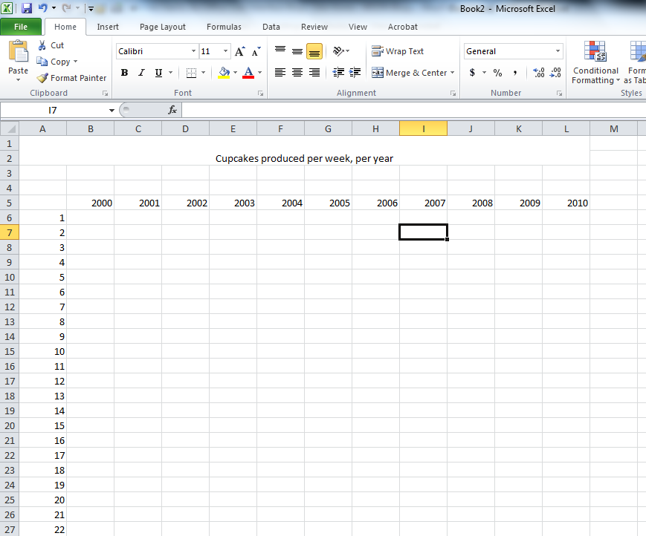

Now that you have set up your spreadsheet, you must populate it with data. You could enter random values by hand, but that would mean individually entering data into 300 cells in this case. As we need some numbers to work with, and it isn’t important that these numbers really mean anything significant, we can use the random number generator to fill the cells with information. To do this, select the cells that we want to fill.
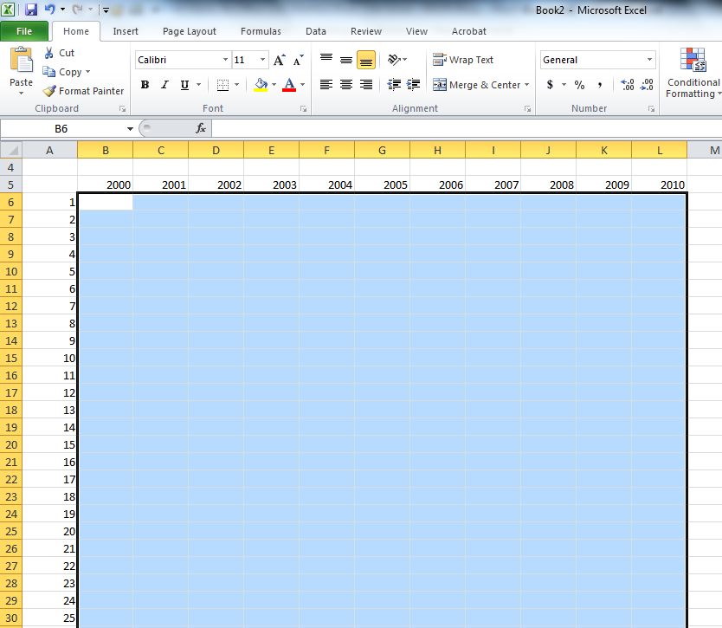

Now, enter the following formula in the formula window:

Then hold down control and press enter. You should now see the following in your table:
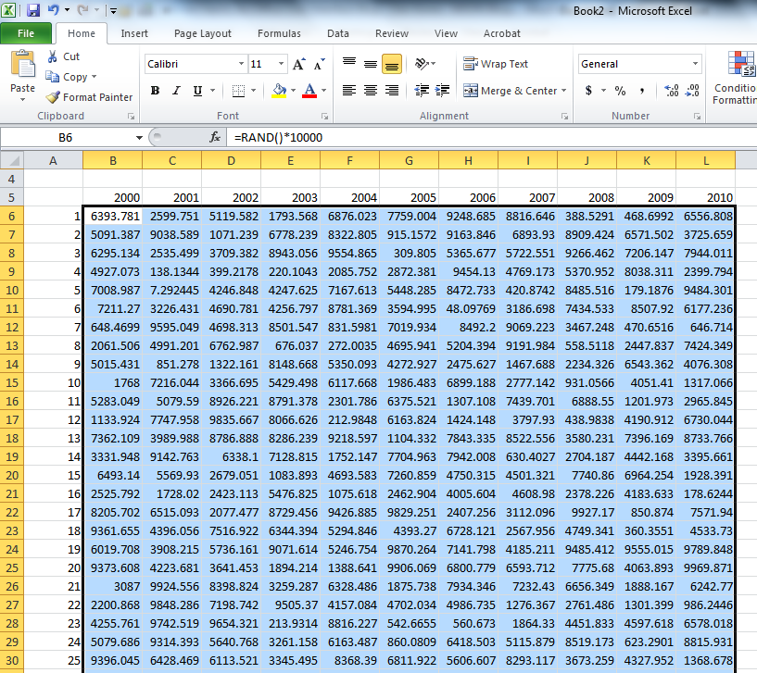
Your numbers should be different than the example. The formula that was entered is telling the program to calculate random numbers between 1 and 10000 (you can change the upper limit by entering a different value in the formula eg. *100 would leave you with numbers no higher than 100).
Now that you have filled the table, calculate the sum of each row in the M column.

When you have completed this, you need to make a bar chart with columns with a label on the top for your table of values, do not include the sum column that you have just created. Add this chart to sheet 3. See below for example.

Name your assignment lastname.firstname.excel2. Hand in to the I drive. Ensure that you have the store table on sheet 1, the random table on sheet 2 and the chart on sheet 3.

