Adobe Animate Shortcuts/Hotkeys

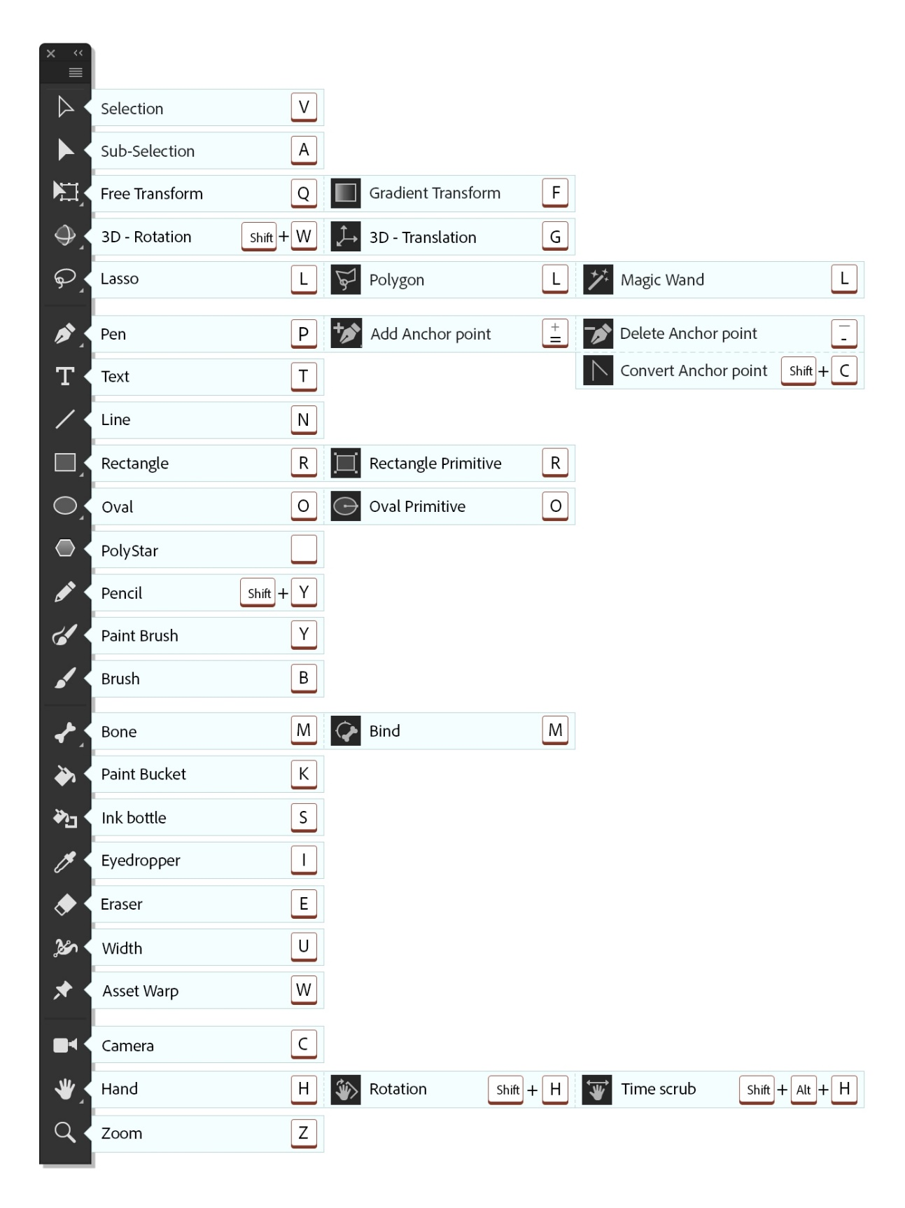

File
Action | Windows
Import Image/Sound/etc... | 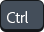 +
Export Movie | + +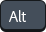 +
Open as Library | + +

View
Action | Windows
View movie at 100% size | +
Show Frame | +
Show All | +

Windows
Action | Windows
Show/Hide Library | +
Comment selection | +
Toggle between Edit Movie and Edit Symbol Mode | +
Show/Hide Timeline | + +

Edit and modify
Action | Windows
Group | +
Ungroup | + +
Break Apart | +
Paste in Place | + +
Duplicate | +
Select All | +
Deselect All | + +
Import Library | + +
Align Window | +
Save As | + +
Scale and Rotate | ++
Remove Transform | + +
Move Ahead | +
Move Behind | +
Bring to Front | + +
Send to Back | + +
Show or hide Transform Panel | +
Narrower letterspacing (kerning) | ++
Wider letterspacing (kerning) | ++

Miscellaneous actions
Action
Remove rotation or scaling from the selected objects | + +
Rotate the selection to 90 degrees left | + +
Scale and/or rotate the selection using numeric values | + +
Auto formats the editor code | + +
Show hidden characters | + +
suppresses highlighting of selected items | + +
Show or hide the rulers | + + +
Show Frame Script Navigator | + +
Show or hide the tweening shape hints | + +
Show a smaller area of the drawing with more detail | +
Show a larger area of the drawing with less detail | +
Show or hide the Align panel | +
Show or hide the Color panel | + +
Show or hide the Compiler Errors panel | +
Open a new window in the front most simulation that is a duplicate of the active window | + +
Show or hide the History panel | +
Show or hide Info Panel | +
Show or hide the Library panel for this document | +
Show or hide the Property Inspector | +
Show or change a list of the scenes in the current movie | +
Select colors from swatches and manage swatches | +
Show or hide the animation timeline and layers controls | + +
Show or hide the drawing toolbar | +
Increase onion skin marker size on both directions equally | + drag towards right/left
Shifts the entire range of onion skin markers to the right/left respectively. | + drag towards right/left

