Unit 2 Class 7 Reference - Flour sack Inbetweens and clean up:

This reference covers the following topics:

- Inbetweening complex shapes
- Favoured timing and Slash inbetweens
- Final clean up and fill

This reference material goes over how to approach inbetweening complex shapes and cleaning up animation for a final look to the jumping Flour sack assignment.
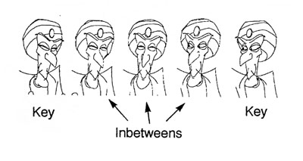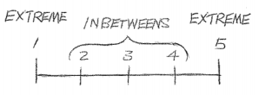
In the previous reference materials you covered timing charts to plan out the action of the Flour Sack, this will cover the implementation the drawing of the chart lines done out on 2’s on the timeline. Then once completed you will clean up the drawings and fill them in with the final fill colour.
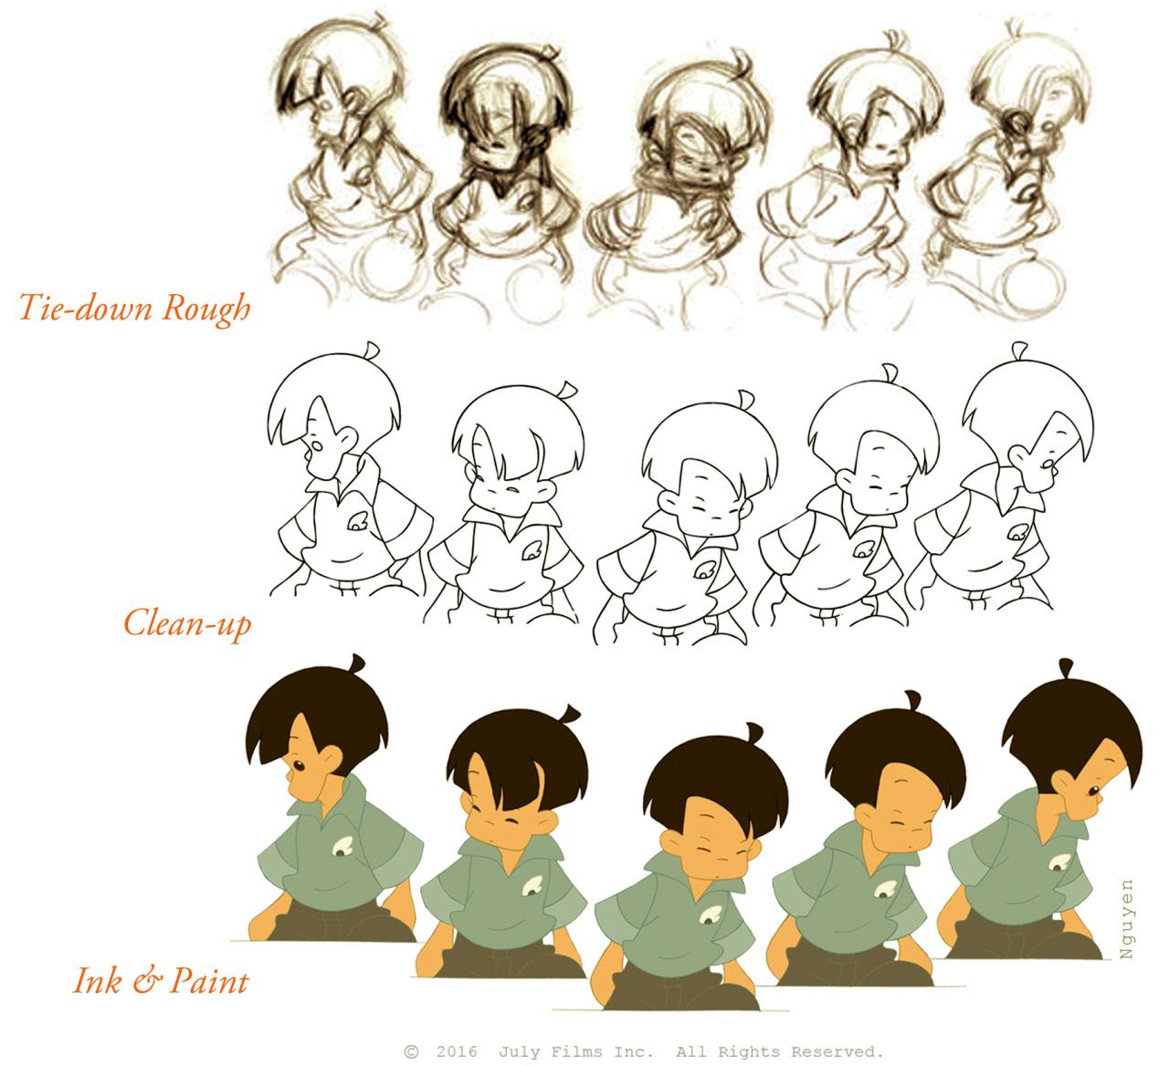

Inbetweening complex shapes:
Like before with the bouncing ball you will be alternating the colours for the inbetweens. Here are a few tips and tricks for figuring out how to animate halves of a more complex shape.

- First find your first inbetween, in this case it is the first half drawing on frame 10.
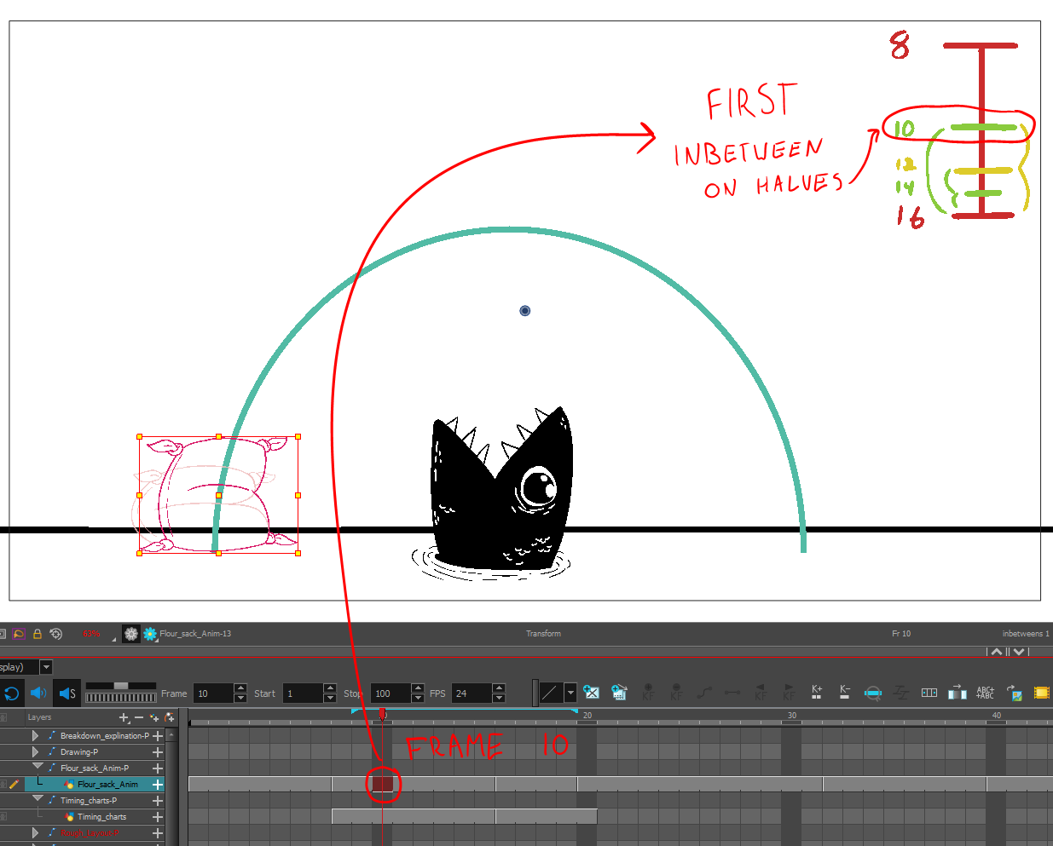

- Start by duplicating the drawing to create a new one to work from.
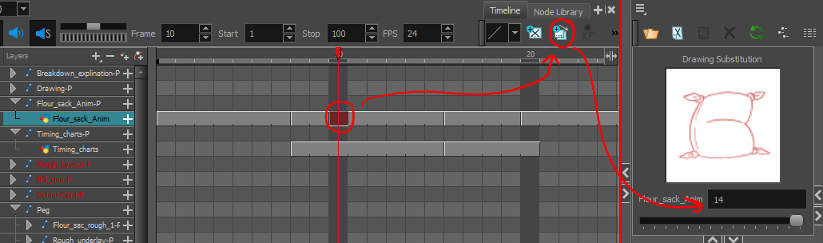

- Then switch to the first inbetween colour swatch in the colour tab to match your chart lines (green).

- Select the parts you don’t need and delete them, like before.
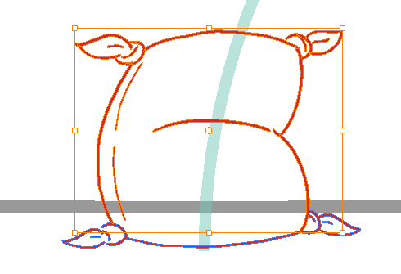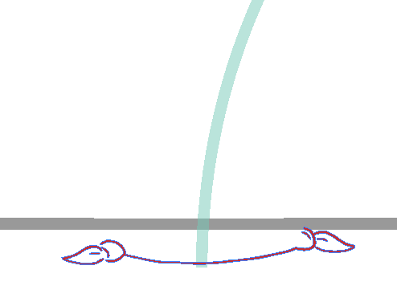
- Recolour what is left with the inbetween colour. Turn on the onion skin to see both keys.
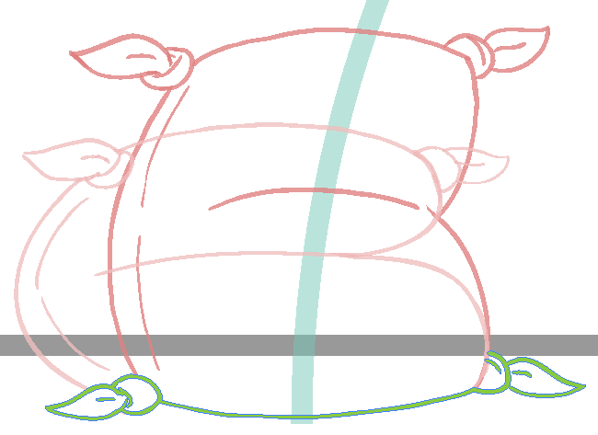

- To find the half line inbetween the two keys start by drawing out connection lines from similar points on the Flour sack, like the top corners.
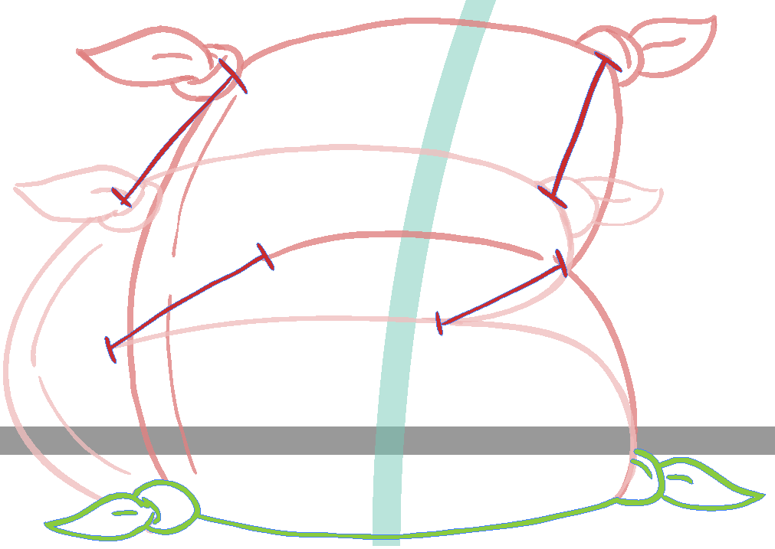
- Now draw in the centre line on the connection lines to get the middle half.
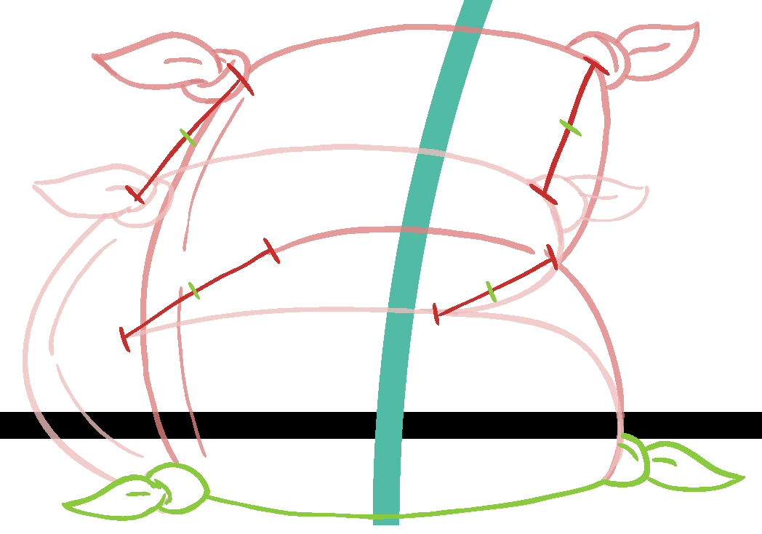

- Remove the connection lines and use the middle half lines to draw in the inbetween lines. Create more connection lines if you need more information to fill in the inbetween.
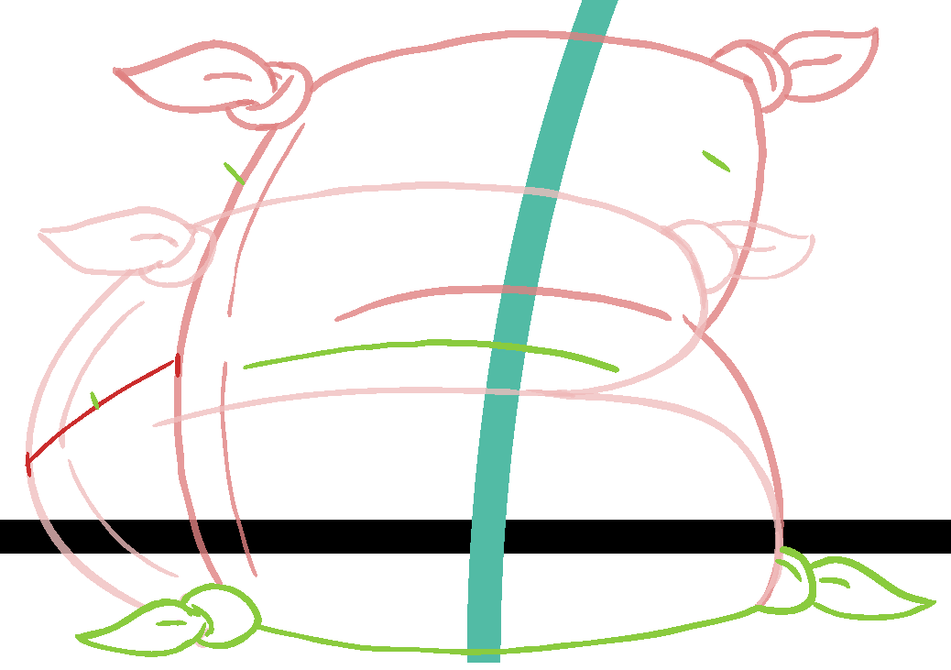

- Continue on to finish the inbetween lines, make sure to consider the curve of the lines. Make sure to draw in the drag of the bag tassels or to leave it and do another pass after.

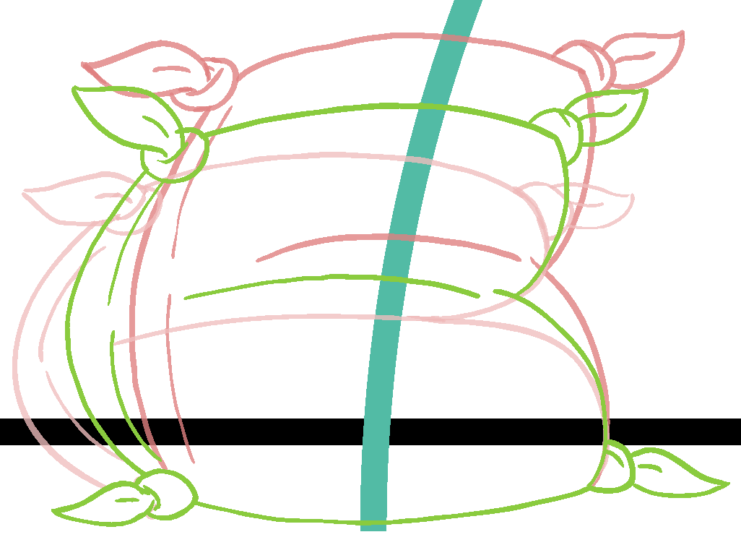

- Move onto the next inbetween on frame 12. Again duplicate the drawing and remove what you don’t need from the last. Use the next inbetween colour swatch for this inbetween (Yellow).
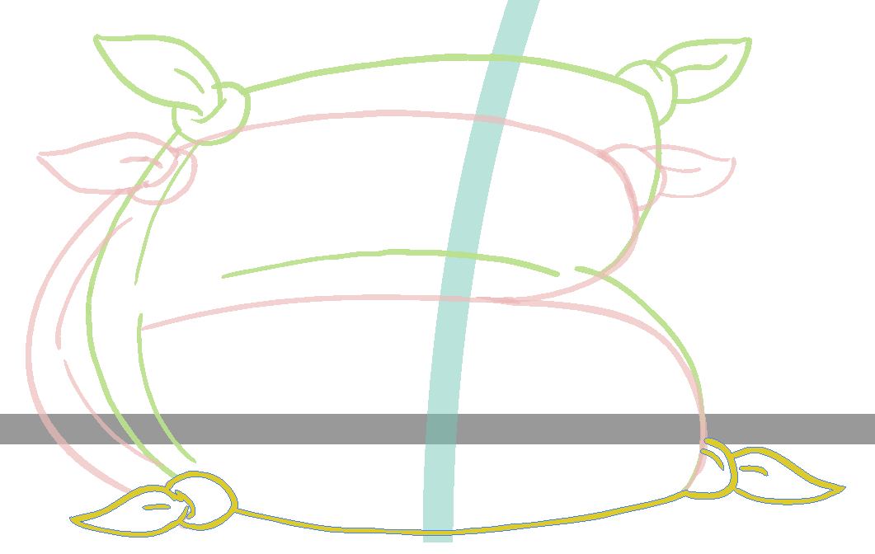

- Again use the onion skin to inbetween the next halved drawing.
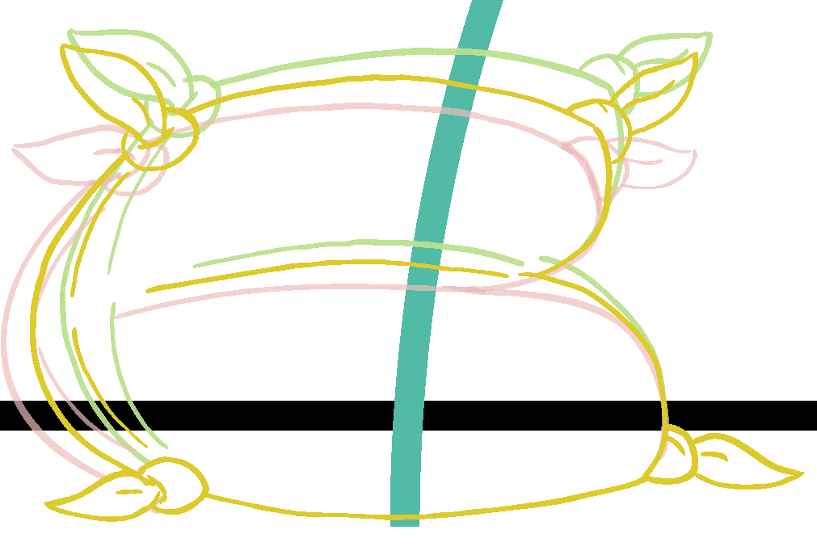
- Continue onto the next inbetween to do the same, this time again alternating back to the first inbetween colour swatch (green).
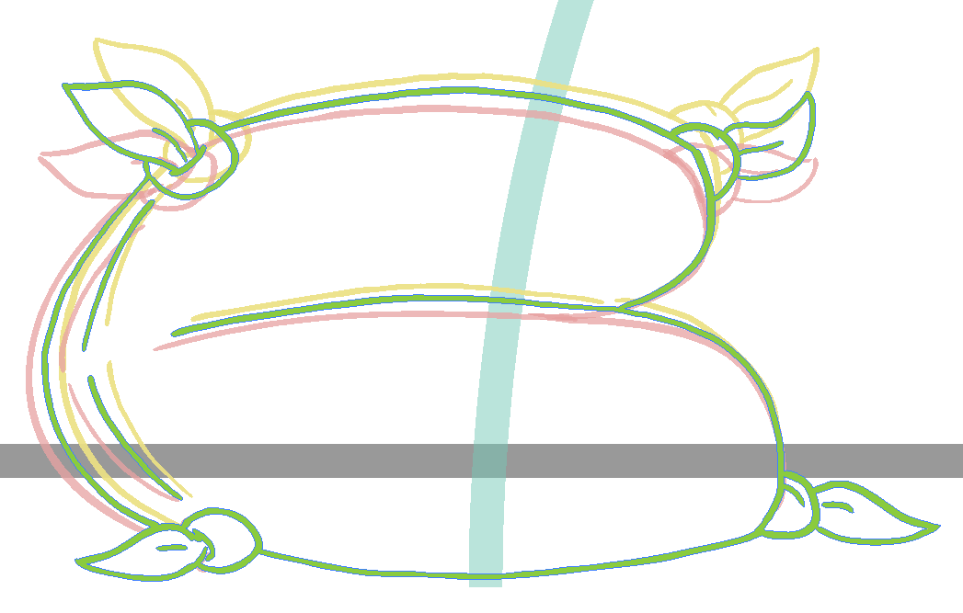

The first two keys are now inbetweened. Scrub through your action and see the result.
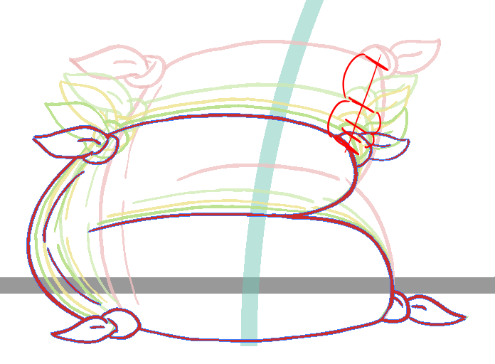

- Use the timing chart spacing to check that everything is working nicely for all the lines. If anything feels off go in and make some adjustments.

Favoured timing and Slash inbetweens:
The next inbetweened action has some favored drawings and slash drawings.
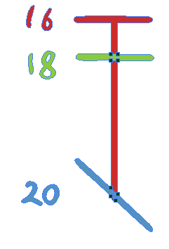
- Start off with the same approach as the last inbetweens. Find it’s spot on the timeline and duplicate the drawing on that frame. Eliminate what you don’t need and recolour the rest to the inbetween colour swatch 1 (green).
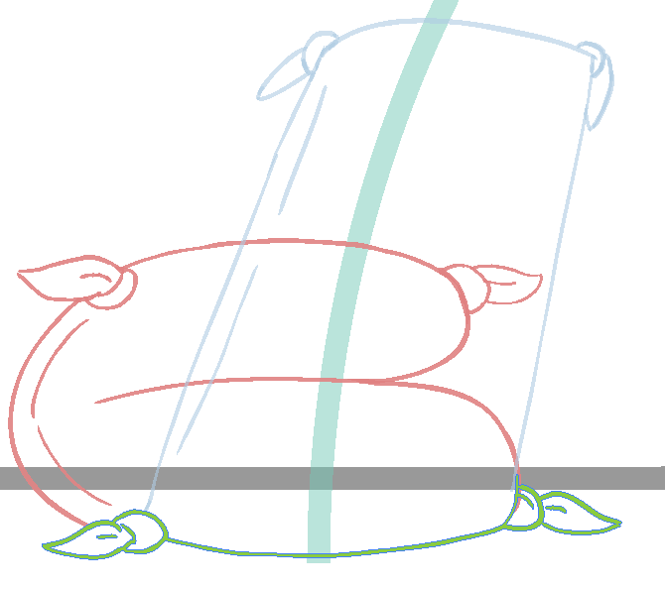

For the favored inbetween you’ll want to do this one with a bit more care for the intent of the drawing. In this case it will be slowing out from the antic and moving slightly into the take off pose.
- You can draw in curved connection lines to see the arc of the favored inbetween.
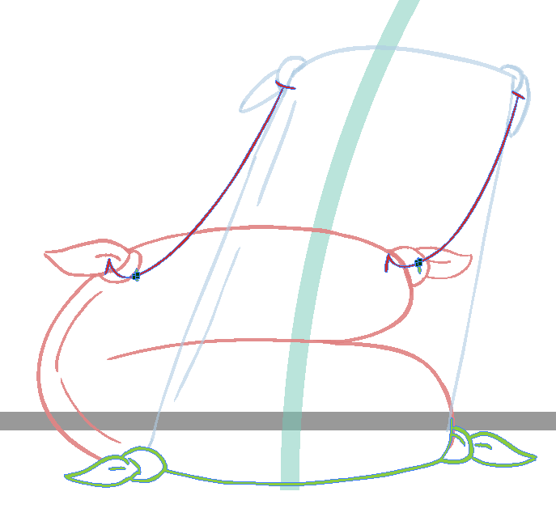
- Fill in the drawing with the arc’s in mind.
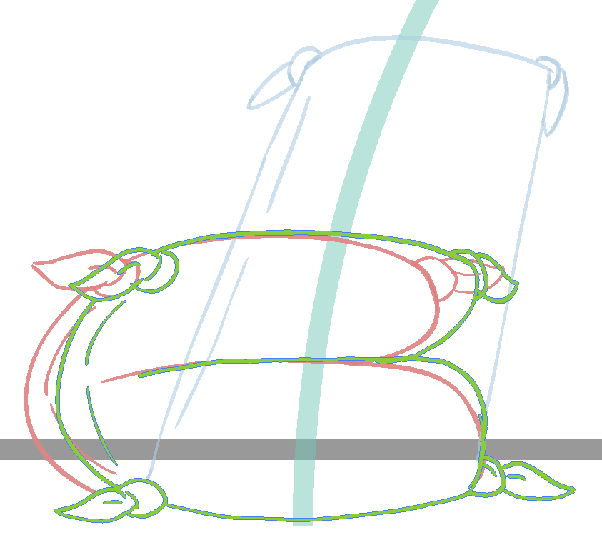

Slash inbetweens:
With the next inbetweens you’ll have to work with the break down as a regular drawing and do out some rough connection point arcs to get the movement and motion you’d like.
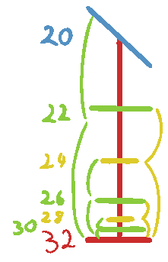
- With the timing chart in mind start with the first inbetween on frame 22, due to the nature of the previous breakdown acting as a key this inbetween may also act as a type of breakdown.
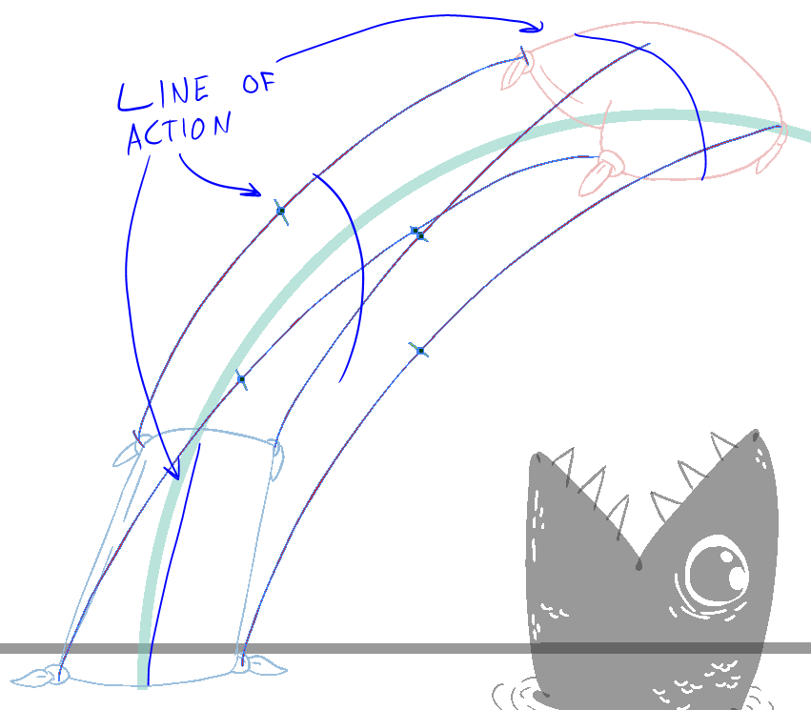
- Once you have figured out the movement and line of action of the first inbetween. Continue onto the next ones up to the peak key pose.
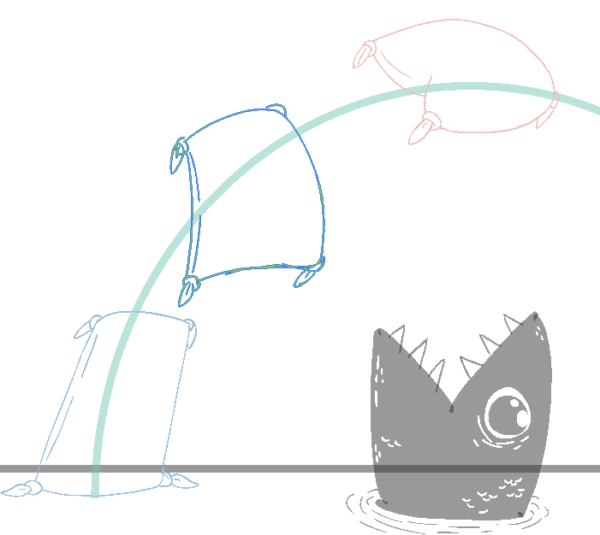

Finished it should look something like this.
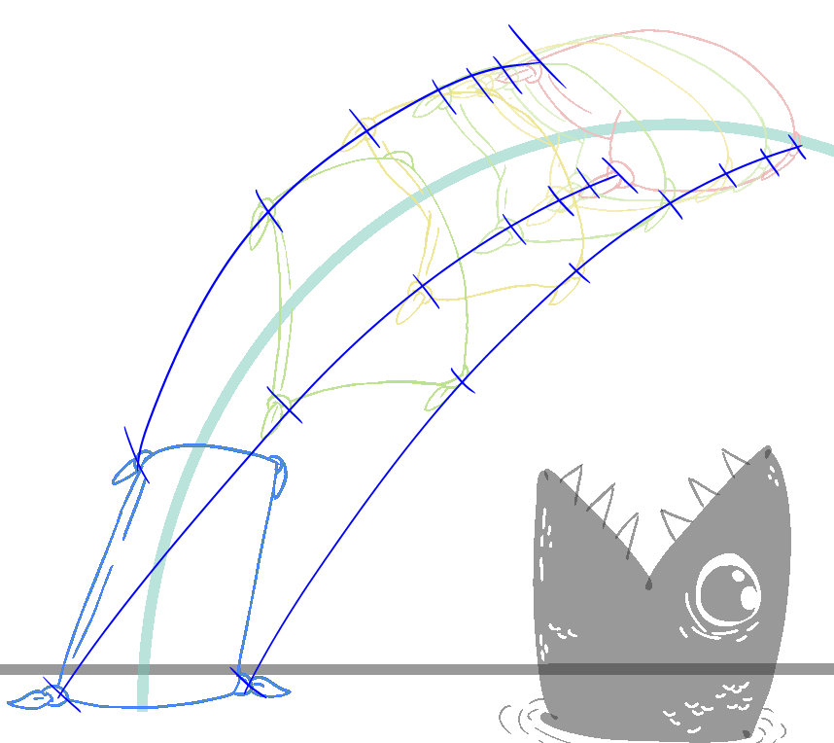

- Continue on to finish the next half of the jump. The chart lines might look something like this as you are now inbetweening it out of the peak and into the landing.
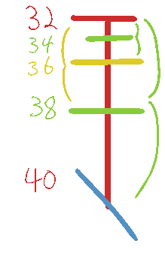
- Finished it should look something like this.
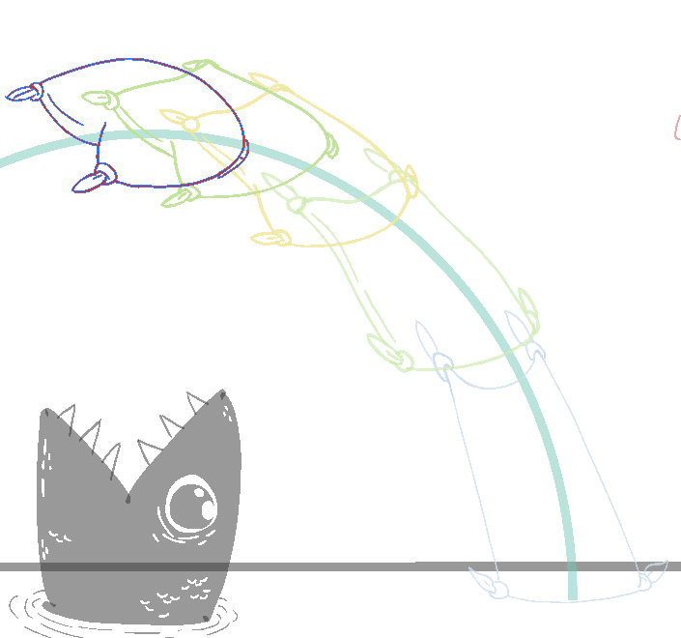

- Continue on and finish the entire Flour sack inbetweens.
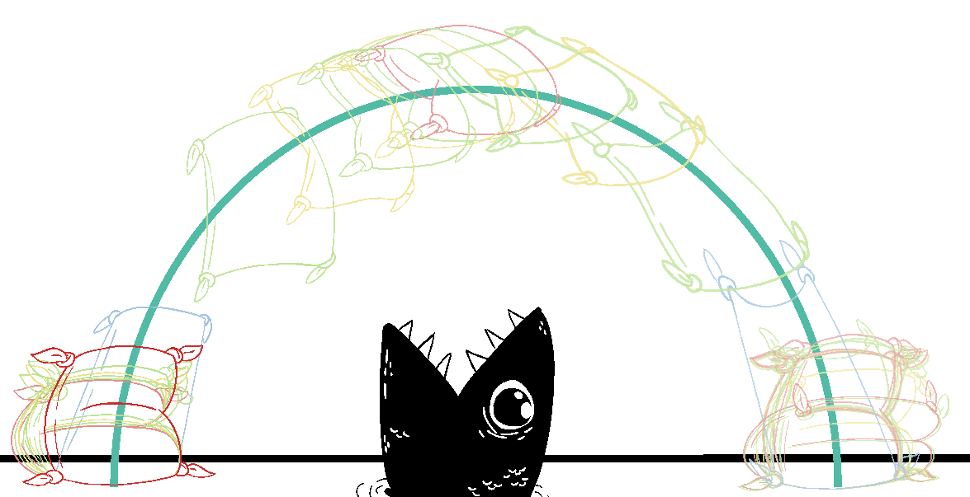

Final clean up and fill:
Once the keys, breakdown, and inbetweens are done, go through a do a final clean line pass to make sure all of the lines are closed off and the tassels are not overlapping the body of the Flour sack.

- Once the lines are all cleaned up you’ll want to change the colour of the line on all of the drawings to the proper clean line.
- Select the “Flour sack Clean line 1” colour swatch.
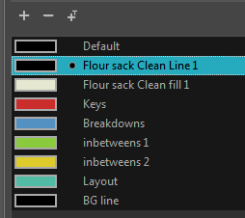

- Then select the “Repaint tool” from the paint bucket drop down.
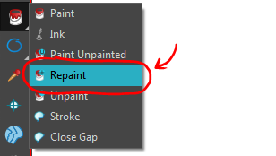

- With the “Repaint tool” selected go to the tool properties. And select the option for “Apply to multiple drawings”
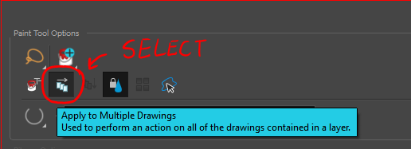

- The “Apply to multiple drawings” function lasts for one use then toggles off again. With the “Repaint tool” still selected and inside the “Flour sack Anim” layer, lasso the entire region that the flour sack animation sits within.
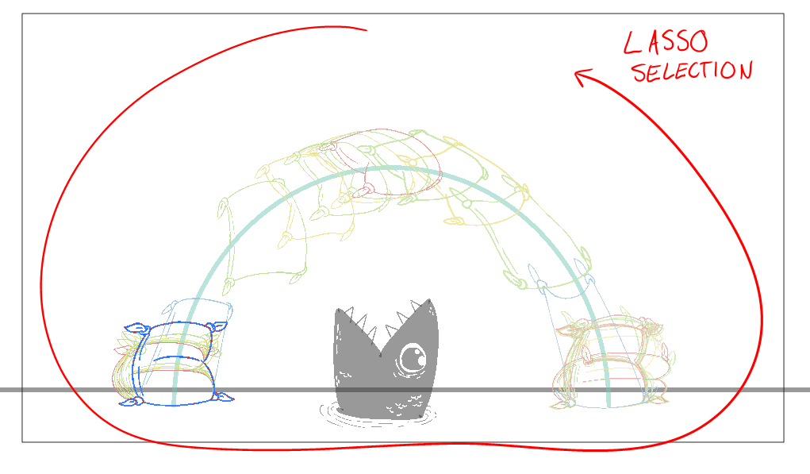

- All of the drawings should change to the new selected colour swatch.
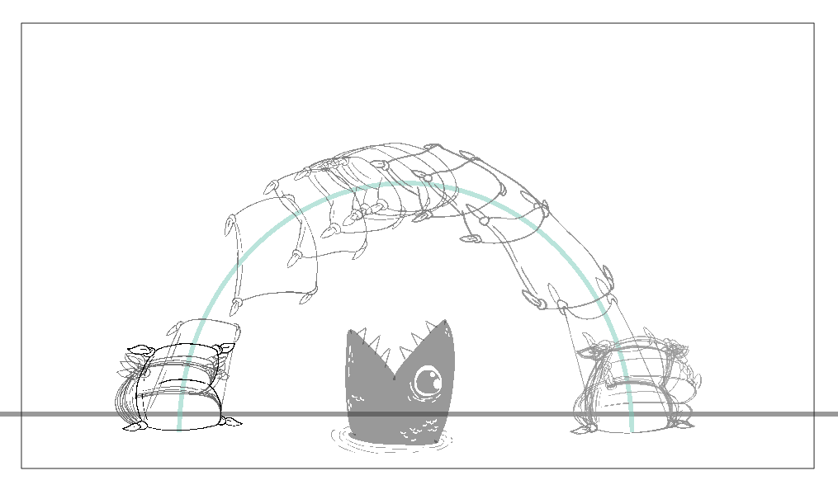
- Next you’ll want to fill in the Flour sack with the “Flour sack Clean Fill 1” colour swatch.
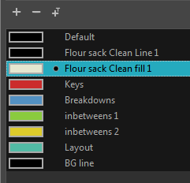
- This time select the “paint unpainted tool” from the drop down. Again in the tool properties select the “Apply to multiple drawings” function

- Do the same thing and lasso the entire region of the Flour sack animation. As long as the lines are closed off properly you will notice the Flour sack filled in for all drawings.
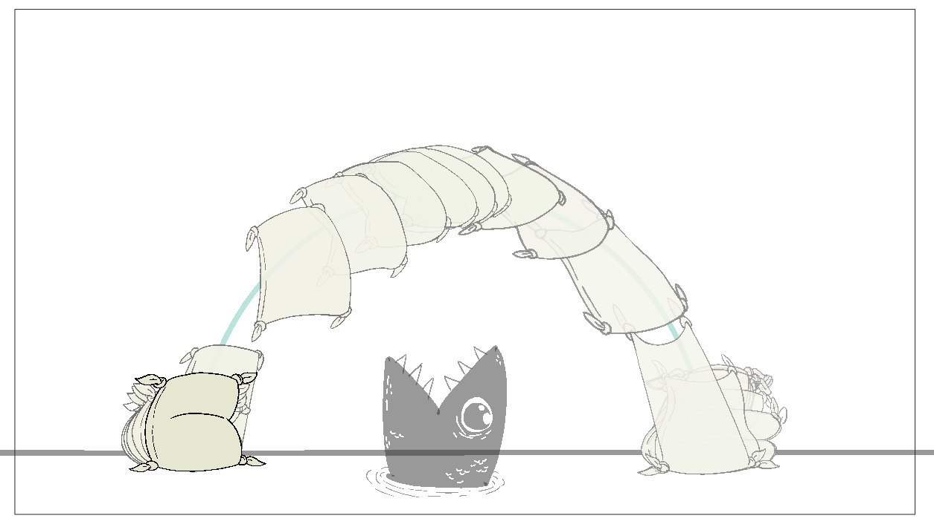
- Some spots might not have filled in entirely, go through and do a manual clean up and fill pass.
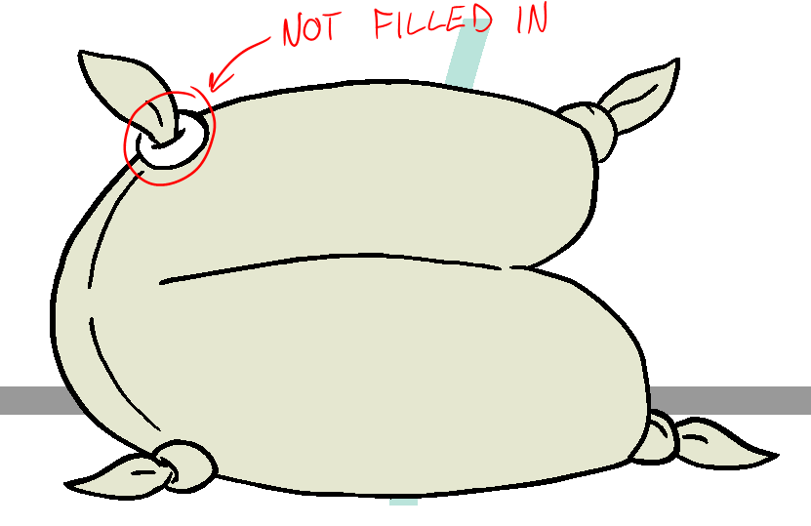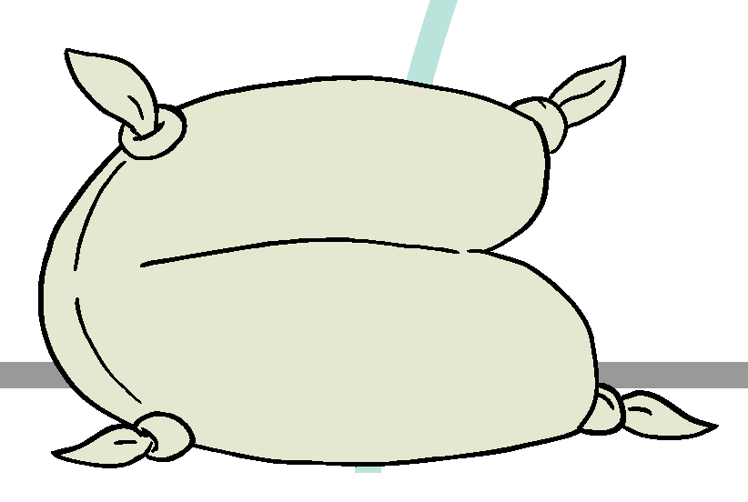

- Scrub and play through you animation a few times, if everything is looking good to go set it to render.
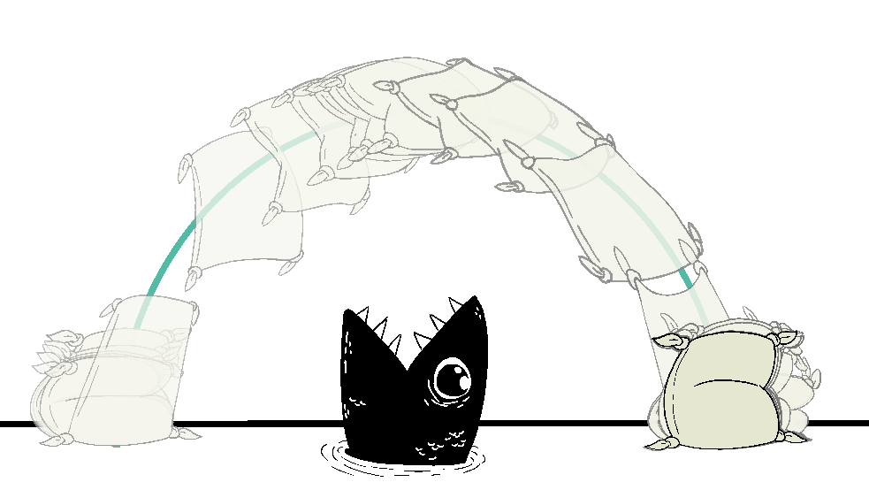

This concludes the jumping Flour sack assignment

