Unit 2 Class 6 Reference - First pass of keys for the flour sack:

This reference covers the following topics:

- Creating the scene
- Breaking down the action
- Creating keys on timeline
- Line of action and volume

The Jumping Flour Sack is a fundamental animation assignment that teaches the basics of anticipation, weight, and form of a character using a simple object. This reference material covers how to approach the flour sack assignment, and it’s first pass of key drawings.

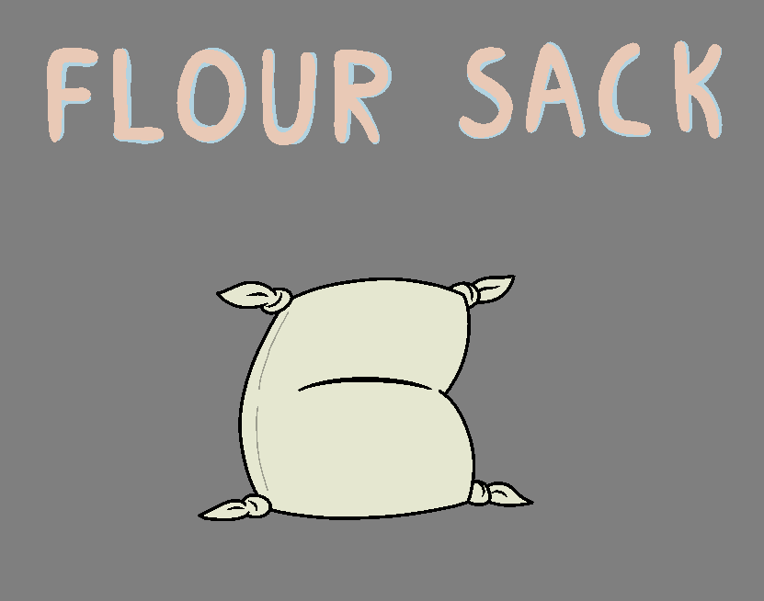
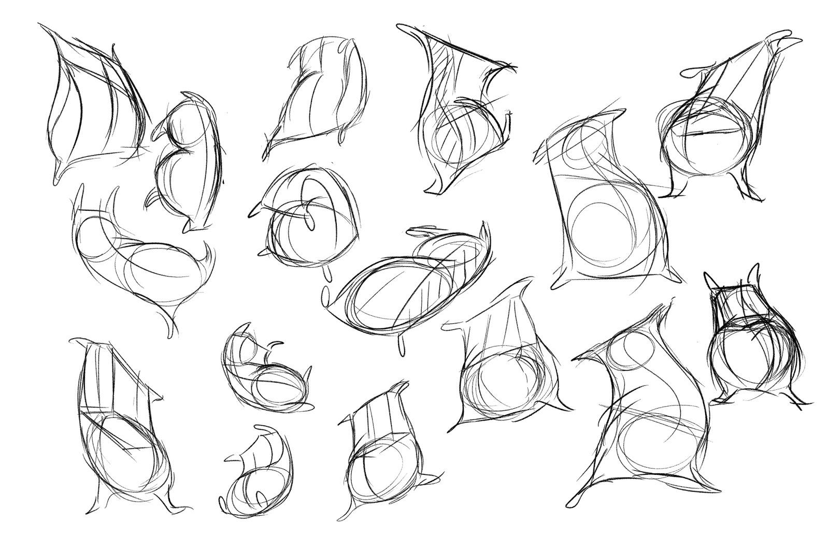

Creating the scene:
Like most of the assignments you will need to create the standard setup to do the Jumping flour sack assignment.

- Start by creating a new scene in harmony called “Flour_sack_1”
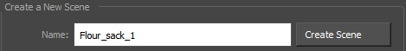

- Create a new palette to work from called “Jumping_Flour_Sack” and create enough colour swatches to match the example below.
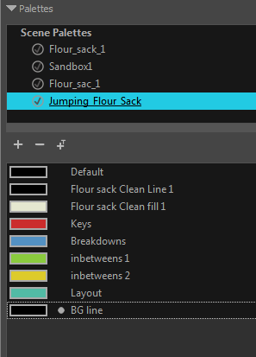

- You will need to create several new drawing layers in the Node view. Create the following and hook them up to the composite bar like so.
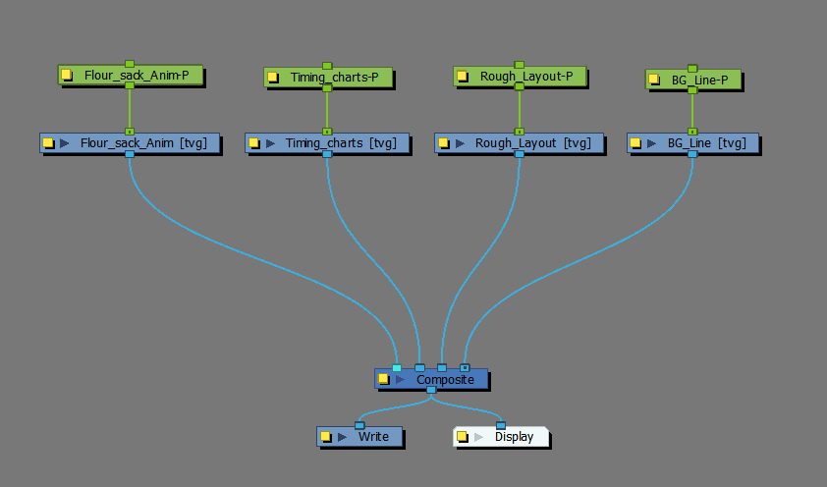
- Pull in a colour card from the Node Library, and hook it up like so.
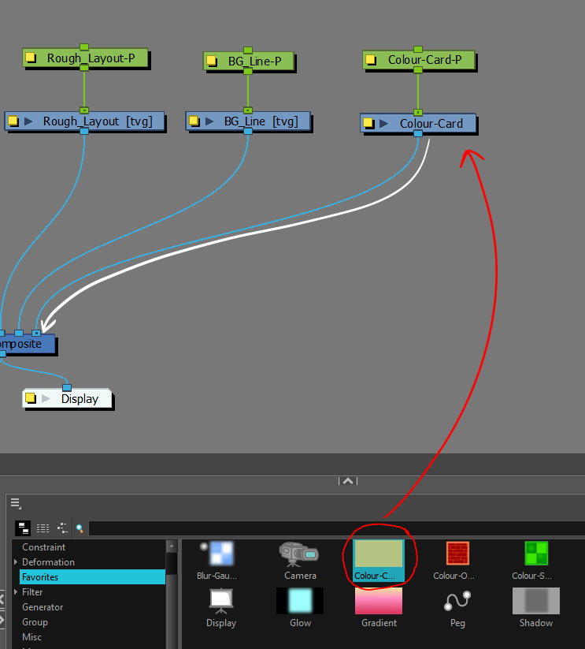

- Next in the “BG_Line” node using the “BG Line” colour swatch create the ground plane for the Flour sack to rest on.

Feel free to draw in something for the flour sack to jump over. Have fun creating a narrative!

- Now lock the “BG_Line” and “Colour card” layers so they can’t be selected accidently.

- Then using the “Layout” colour swatch, create the rough layout of the arc that the flour sack will jump along. this will help to keep the jump consistent, and give you the start and end points.
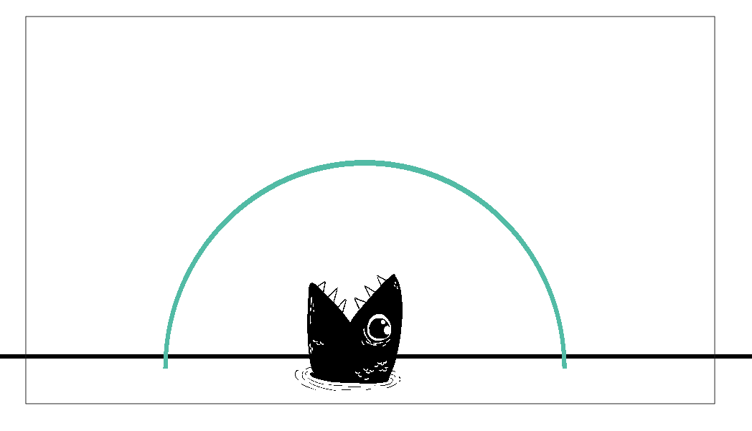
- Lock the Layout layer once you are done.

All that is missing is the character Flour sack.

- In the “Flour_Sack_Anim” Colour art layer draw out your flour sack at rest at the starting position using the “Keys” swatch colour on frame 1.
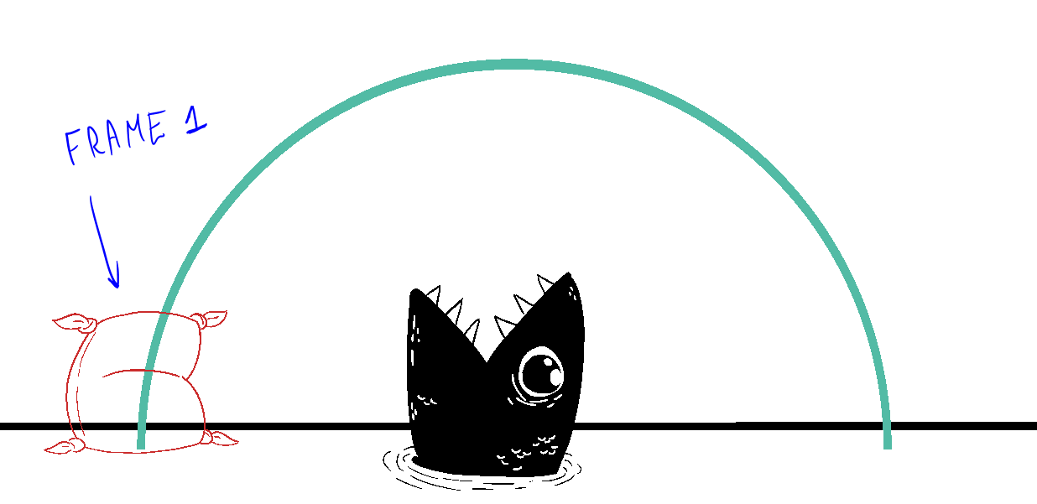

- Once all the layers are in extend the scene to frame 100 and then extend all the artwork layers EXCEPT the “Flour_sack_anim” to the end of the scene using “F5”

Breaking down the action:
For the Flour sack jump, you’ll need to break down the action to find the keys needed. By using action analysis to find which poses have the most contrast in direction and moment, you can find the important storytelling poses for your keys.

Neutral standing pose:
The character or design at rest in a starting position.
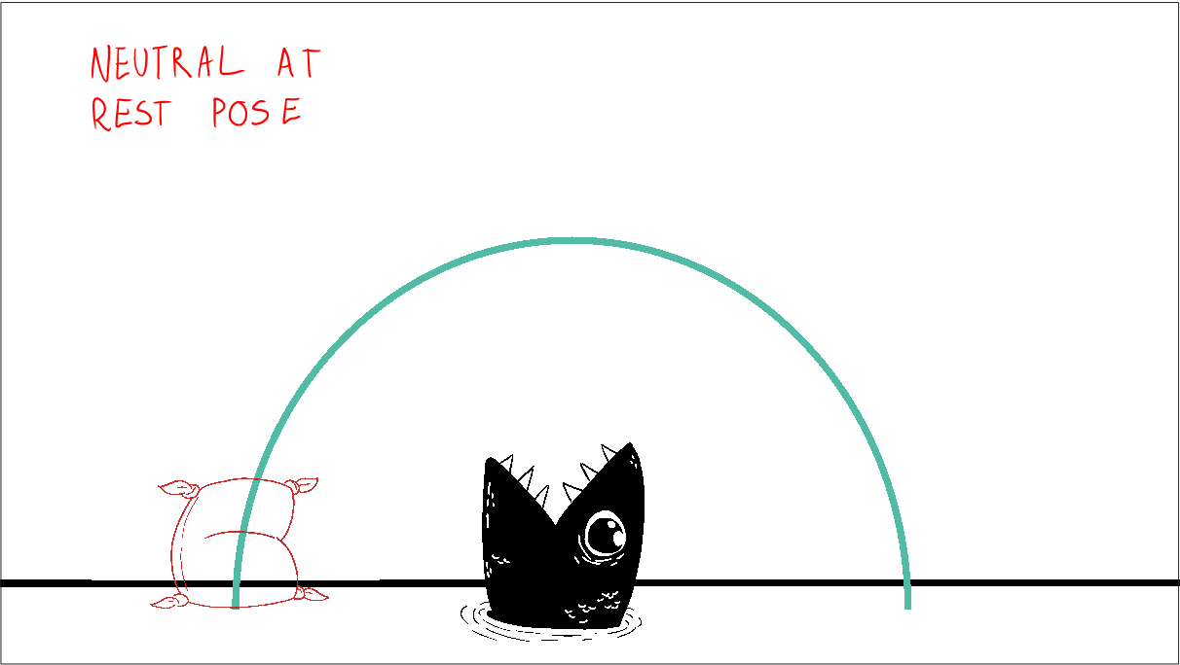

Anticipation:
For the character to jump you’ll first need to have an Antic pose of them building up energy to use for the jump. This is the low point before changing direction into the jump.
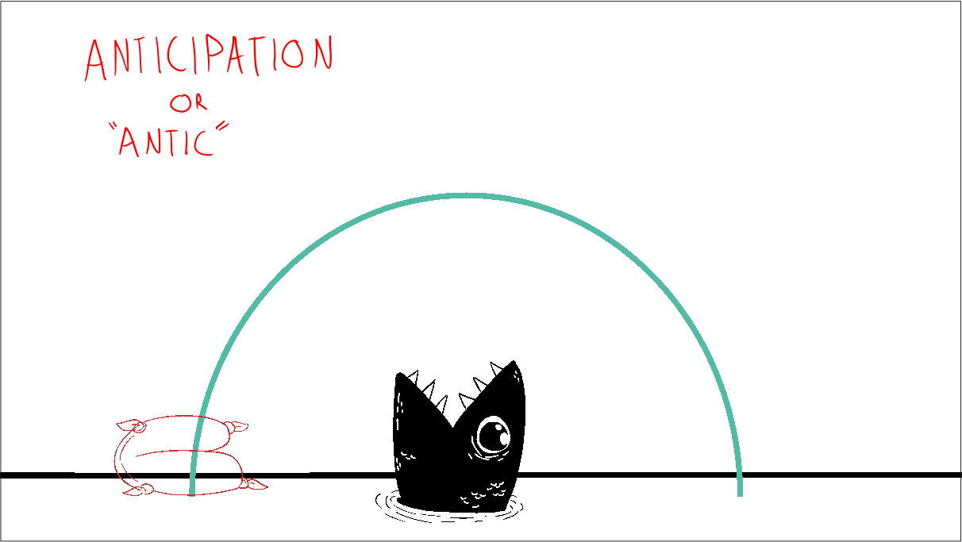

Peak:
The height of the jump. This pose shows the highest point the flour sack gets before it changes direction. Note the drag of the flour sack as the force of the jump propels it.
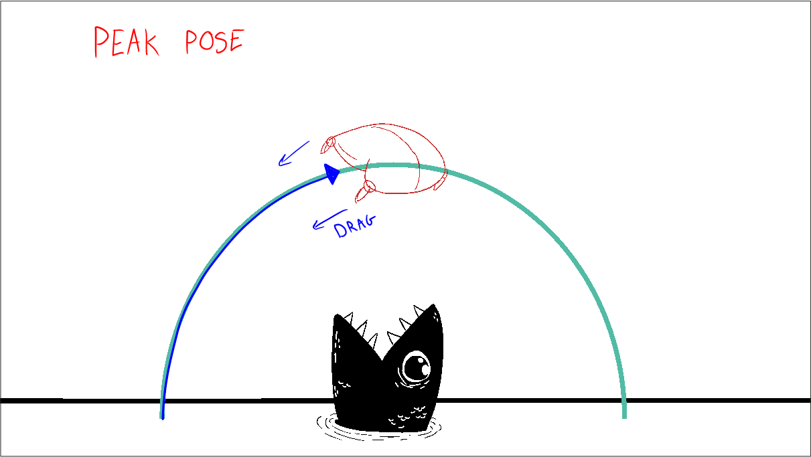

Impact:
The Landing or Impact pose shows the contact to the ground and the force from the jump squishing the character down. This key is used to cushions the impact and feel weight.
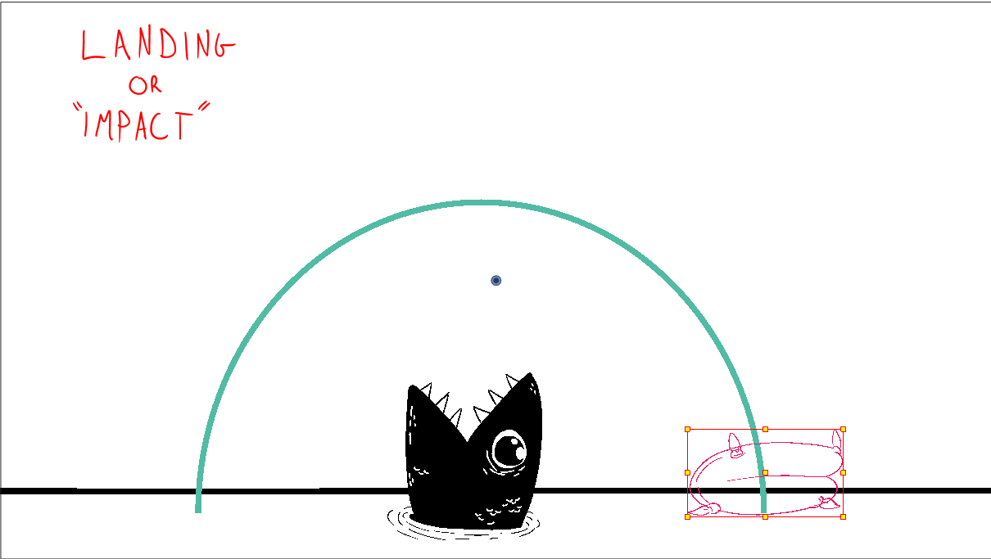

Overshoots:
For the energy of the jump to properly dissipate the character will go through a series of poses that overshoot the settle pose back and forth (in this case up and down) with diminishing force. The Follow through between these poses will keep the object alive and realistic.
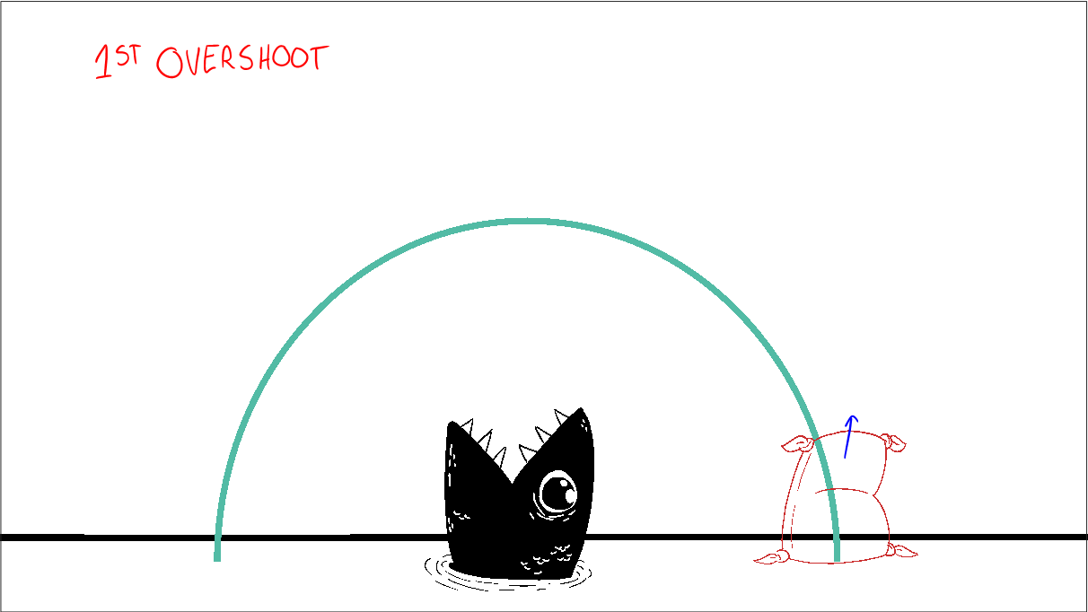

Once a character overshoots the amount of diminished overshoots after will depend on the action and force the animator wishes the object to embody. The more overshoots the more the spacing will grow exponentially smaller.

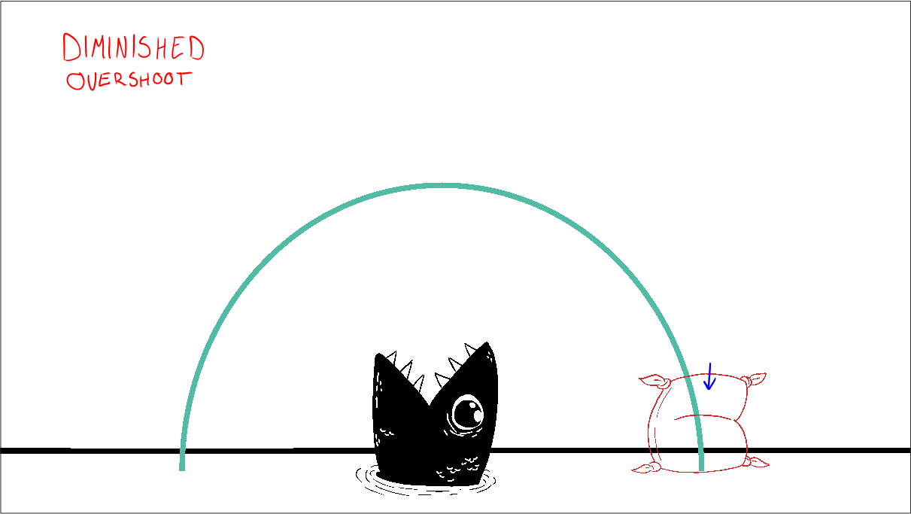
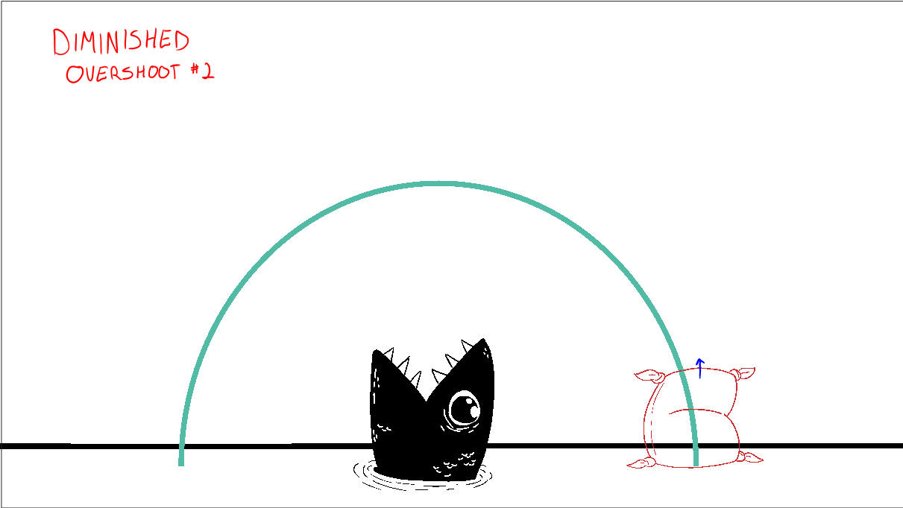

Settles:
After an action occurs of a character or object they will come to rest in a settle position.
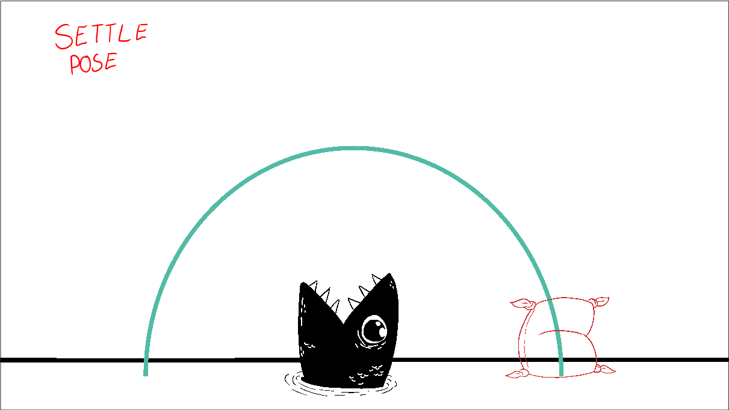

Settles usually have tighter drawings leading up to them to show the object coming to a slow and eventual stop.

With the Keys poses in mind it’s time to draw them out in the timeline in order.

Creating keys on timeline:
Like with the bouncing ball you’ll want to draw out the keyframes one after another on the frames next to each other for each of inbetweening. Later the keys will be shifter along the timeline to accommodate Breakdowns and then finally the blocked out timing of the action.

- In the “Flour_sack_anim” layer extend the first drawing to frame 2 using “F5”
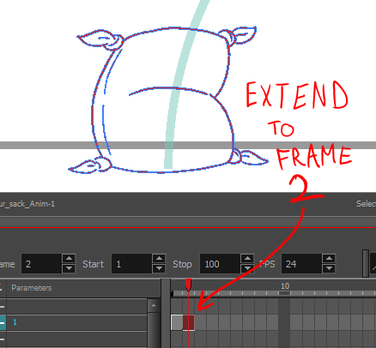

- With the frame 2 drawing selected click the “Duplicate drawing” tool on the toolbar
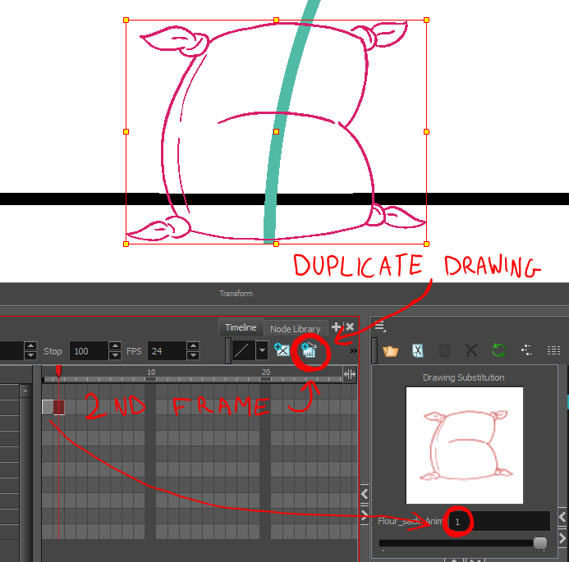

Once the drawing has been duplicated the number in the Drawing substitution window will go up by 1.
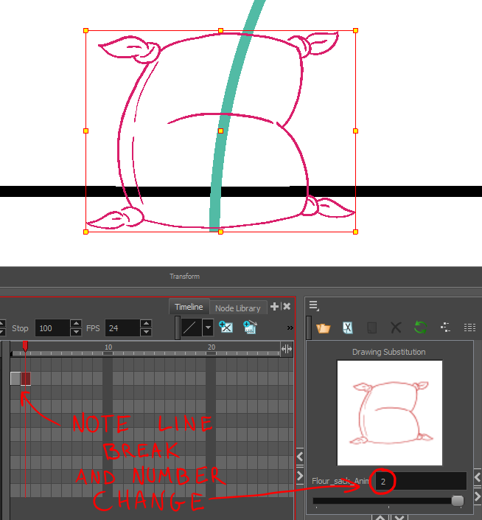

Once the Drawing number changes the drawing has been copied and changes to drawing 2 will not affect drawing 1.

- Remove the parts you don’t need for the next antic pose. Keep the base to have the flour sack properly planted to the ground.
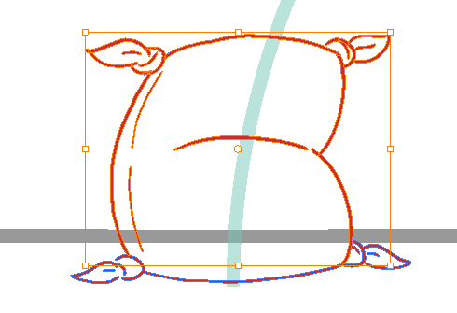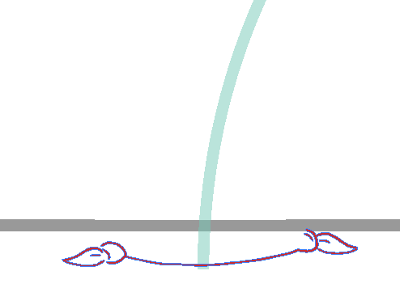

- Once the Base is left draw in the next antic pose. Use the onion skin to see the previous Frame 1 pose.
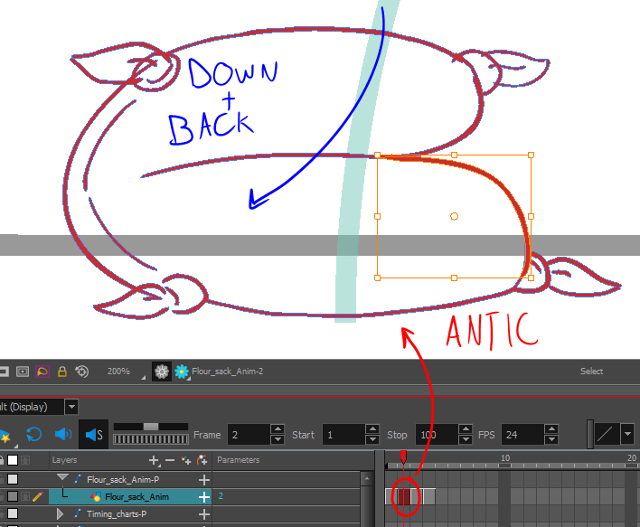

- Move over to the next frame and draw in the Flour sack at the peak of the jump next.
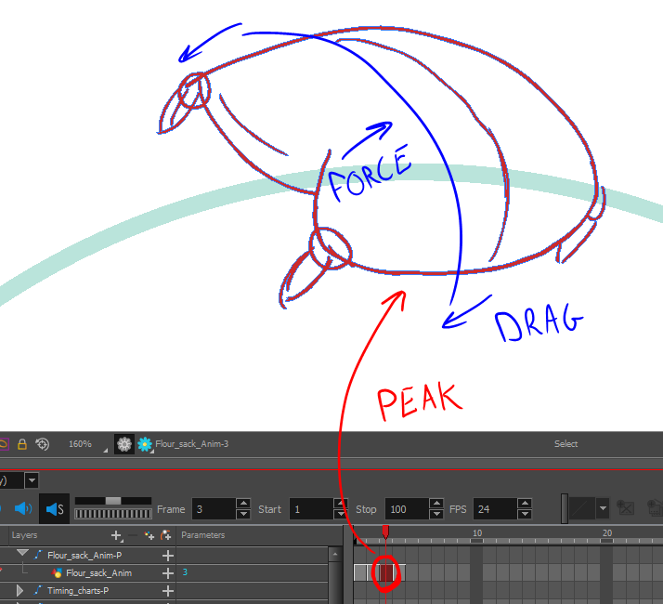
- For the next key pose, go inside the drawing on frame 1 and copy the artwork. Move to frame 4 then paste the drawing in the camera. This will create a new drawing. Move over the artwork using the select tool to place it in the landing position.
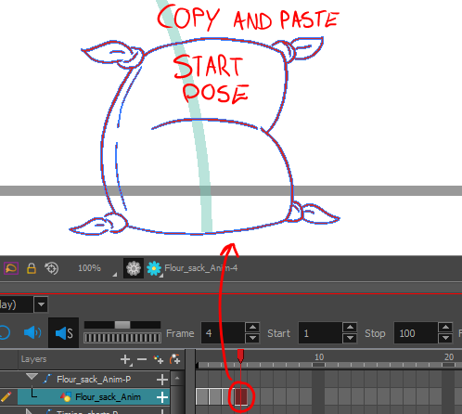

- Extend the drawing for several frames using “F5”, you’ll want to use the base of the resting pose for the next few drawings. Duplicate the drawing on each frame.
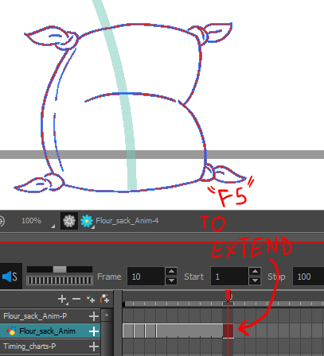
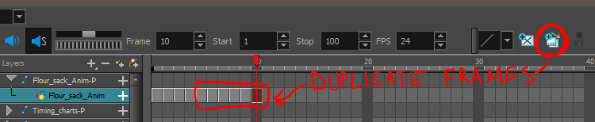
- Change the Drawing on frame 4 to the Landing/Impact pose. Leaving the base the same.
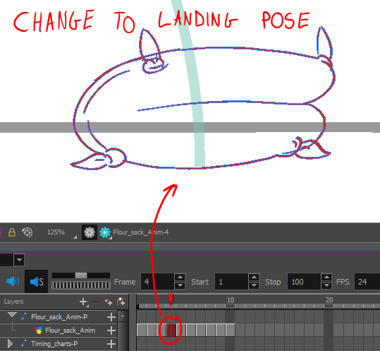

- For the next few drawings go through to add in the overshoots. Make sufre again to leave the base and draw in or adjust the drawings using the select and contour editors.
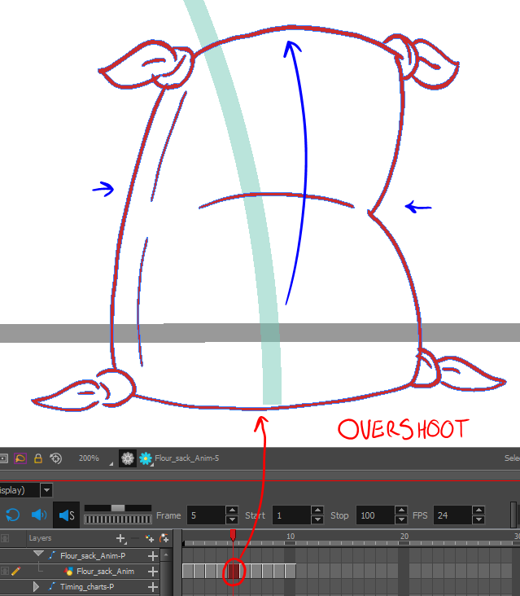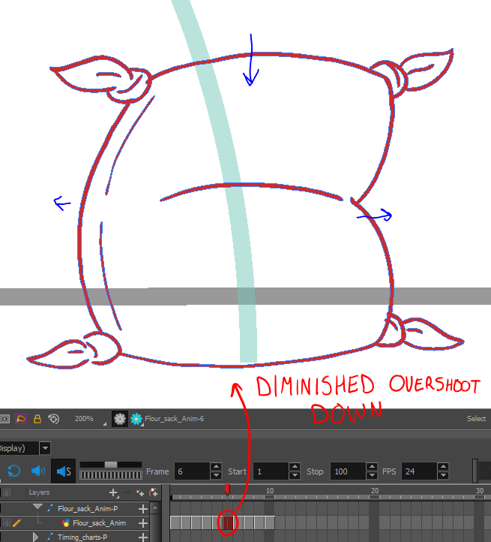

Continue with this to get into the final settle pose.
- For the final settle pose you should have at least one drawing left over of the neutral stance pose.
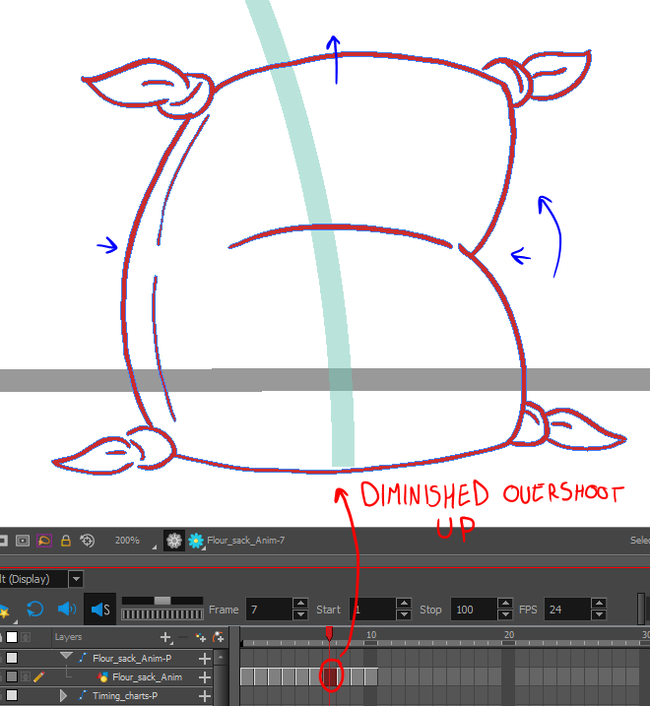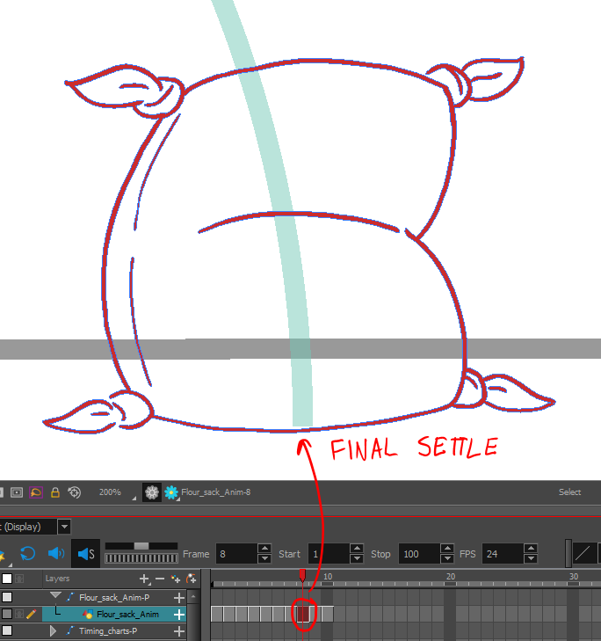

- Delete any extra drawings you might have after the settle.
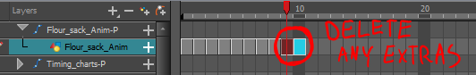

These should be all of your key poses.

Line of action and volume:
When working through these Key poses make sure to start off loose and rough. The most important thing to convey in the pose is the line of action and that the volumes are kept consistent

Line of action:
The line of action shows the line of the character pose emphasizing the direction of force and direction of movement. This is important to make strong key poses.
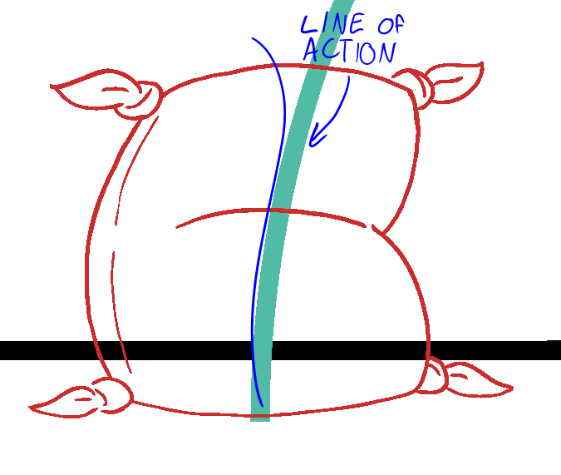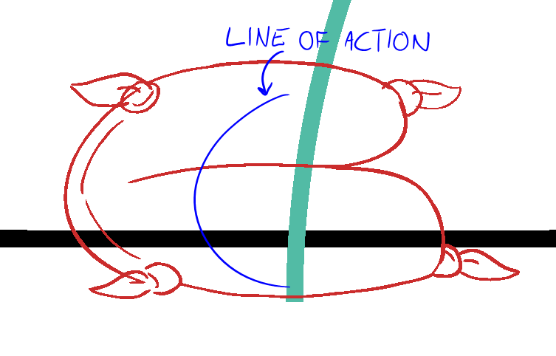
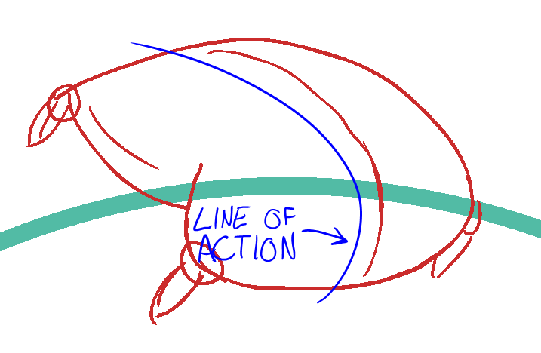

Make sure you are at least in your roughs drawing in or thinking about this line. This will help with your inbetweening pass later as well, if you can track the line of action to inbetween.

Volumes:
The volume of shapes in a character can always be tricky to maintain. It’s dependant on seeing the character with full form, and thinking of the displacement of the shape. The character at rest should be able to fit inside any poses it becomes draw in.
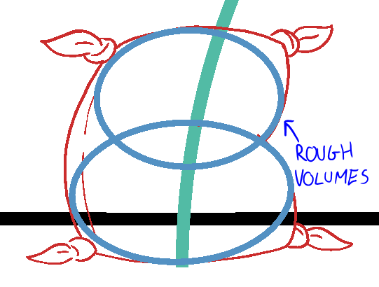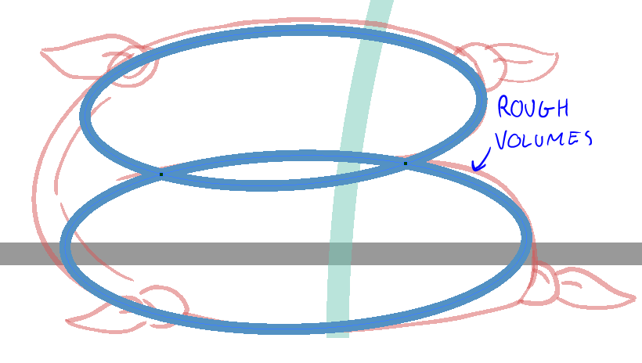
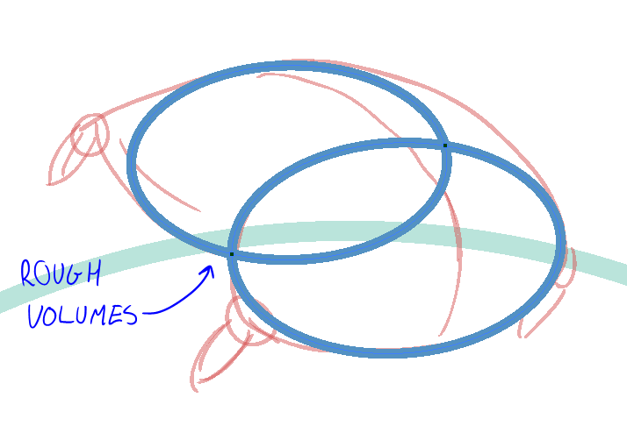

Note the sections of overlap in the circles as well as the portions they don’t cover, they should be about the same. In the peak pose there is a whole portion of the top “arm” that is not shown but should still be considered.
