Unit 2 Class 4 Reference - Setting up pegs:

This reference material covers the following topics:

- Positioning base level Pegs
- Positioning Master Pegs
- Positioning Master + Comp Pegs
- Stress testing the build

This reference material covers how to set up the hierarchy of pegs for the Lamp build. This sets up the articulation of the artwork of the lamp.

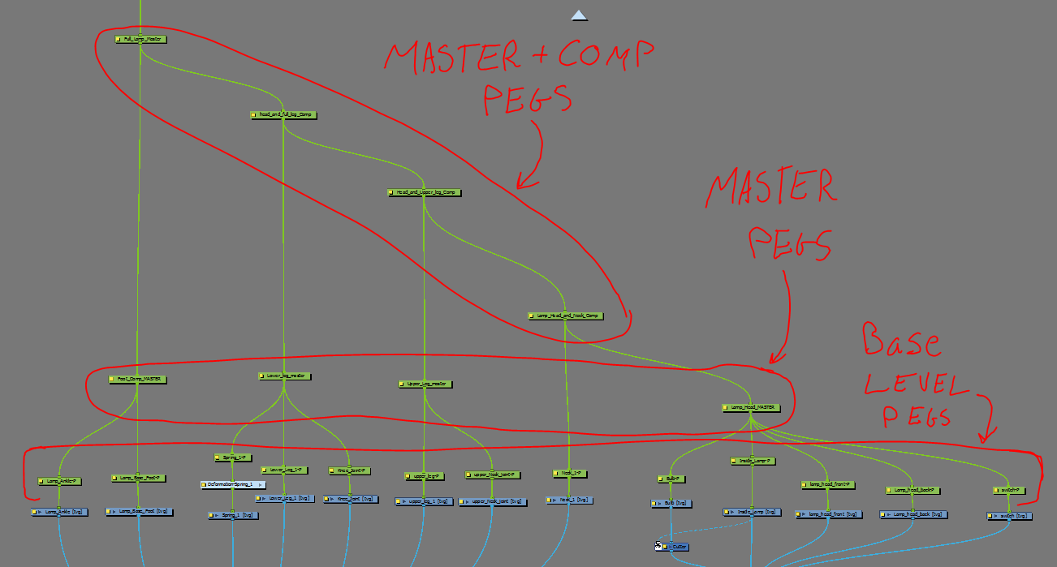

It’s best to set up the lamp build in stages, by starting at the base level pegs it makes it easier to make sure the proper information is going upwards to the master and other parent pegs.

Positioning base level Pegs:
Start again under the “Lamp Head MASTER” Peg. Using the translate tool Setup the base level pegs of the Head node drawings.
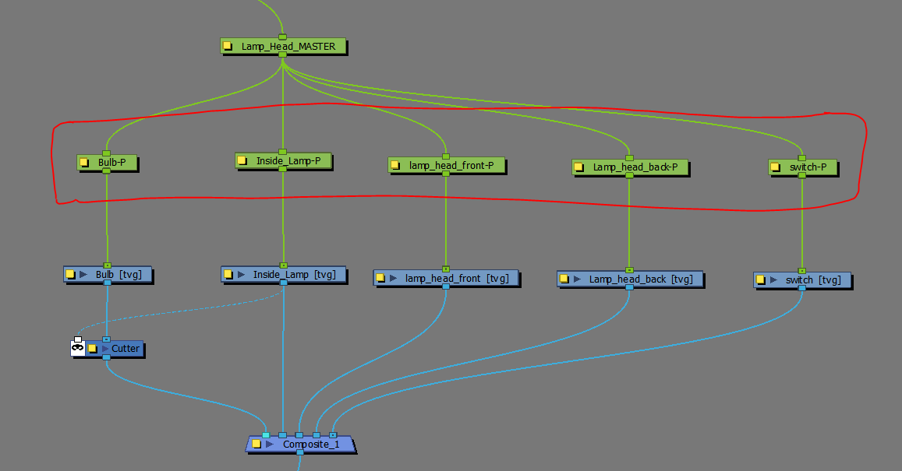

- Make sure they are set up in the most logical position based on Squash and Stretch, Skewing, and Rotation.
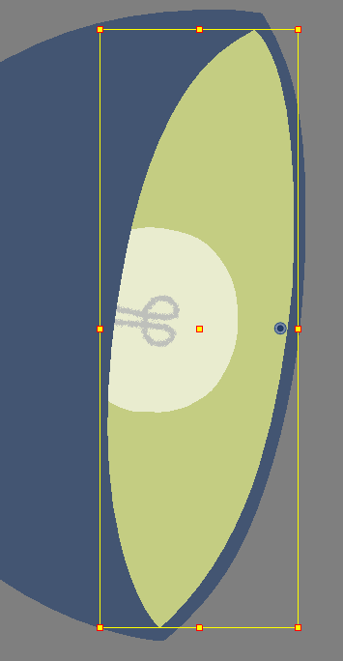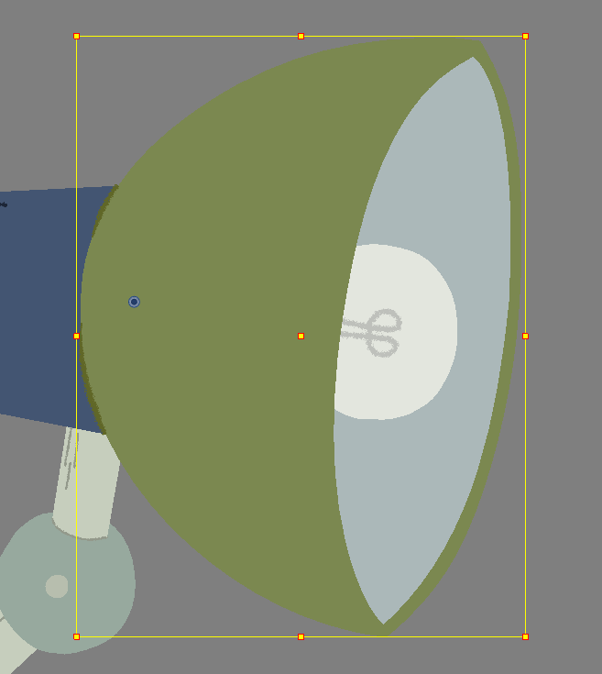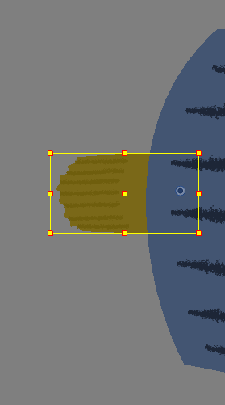
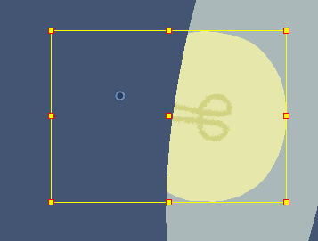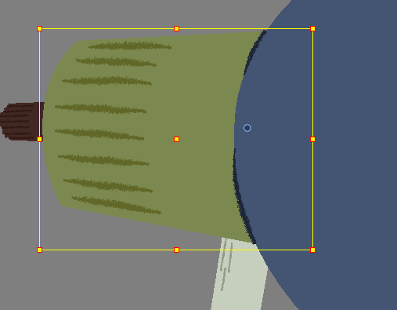
Next move onto the rest of the body base Level pegs to set up the Pivots for the joints and the arm layers. Typically most pivot points are lined up on the artwork themselves, but there are some exceptions.

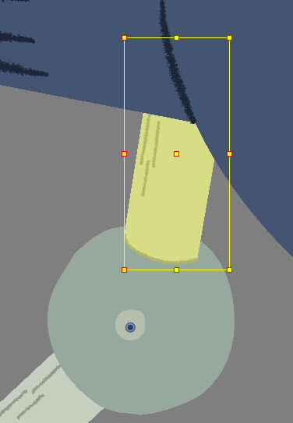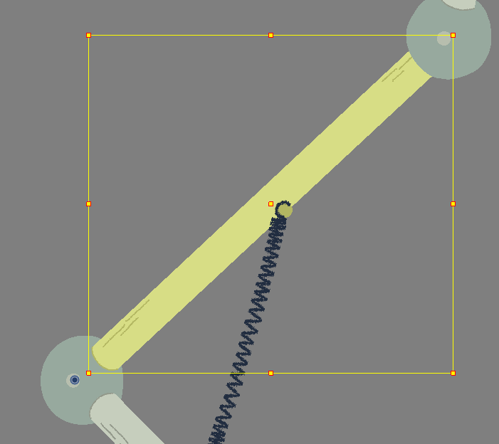

Some Drawings will just have the pivot position placed roughly in the middle of the shape so that it is the easiest and most flexible to make changes.

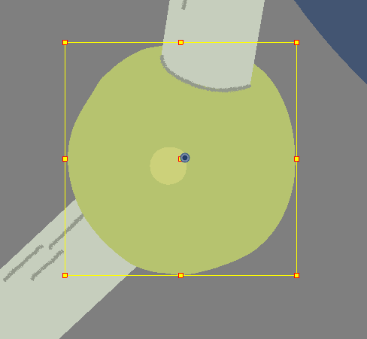

Some Pivot points for object are positioned at their connection points to other objects, this can also make some parts of a rig share the same rough pivot position.
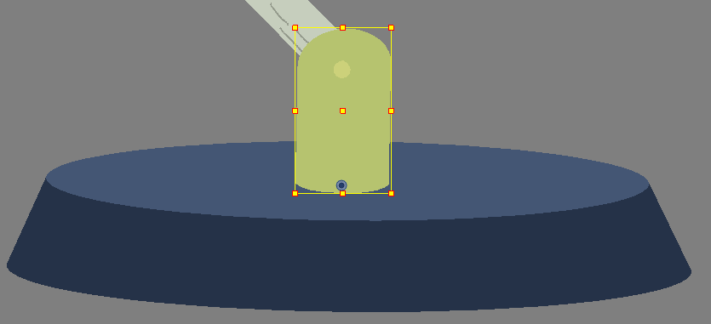
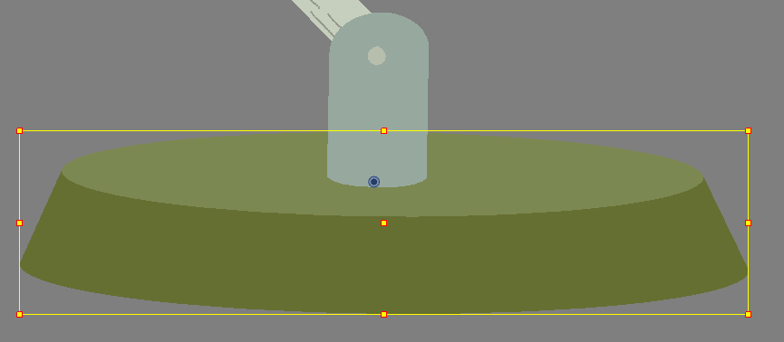

- The peg and artwork for the spring layer will need to be setup in the next class, but the position of the spring should be thought of to where it will be connected to the arm of the lamp.
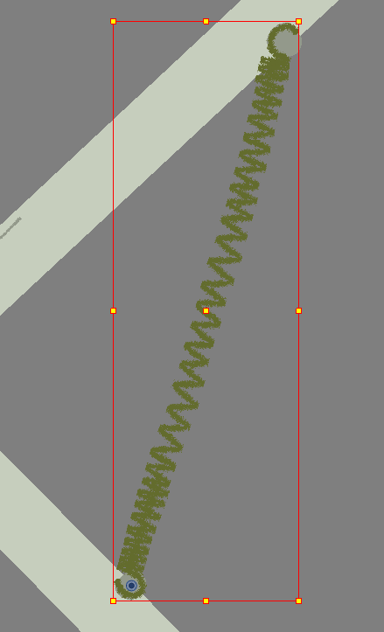

Positioning Master Pegs:
Next you’ll want to group out layers with the logical pivot positions of the Master Pegs.

- Start with setting up the ”Lamp_Head_MASTER” peg. It should feel like it’s rotating from what would seem like it’s neck. *This peg shares no pivot point with any of the base level pegs*.
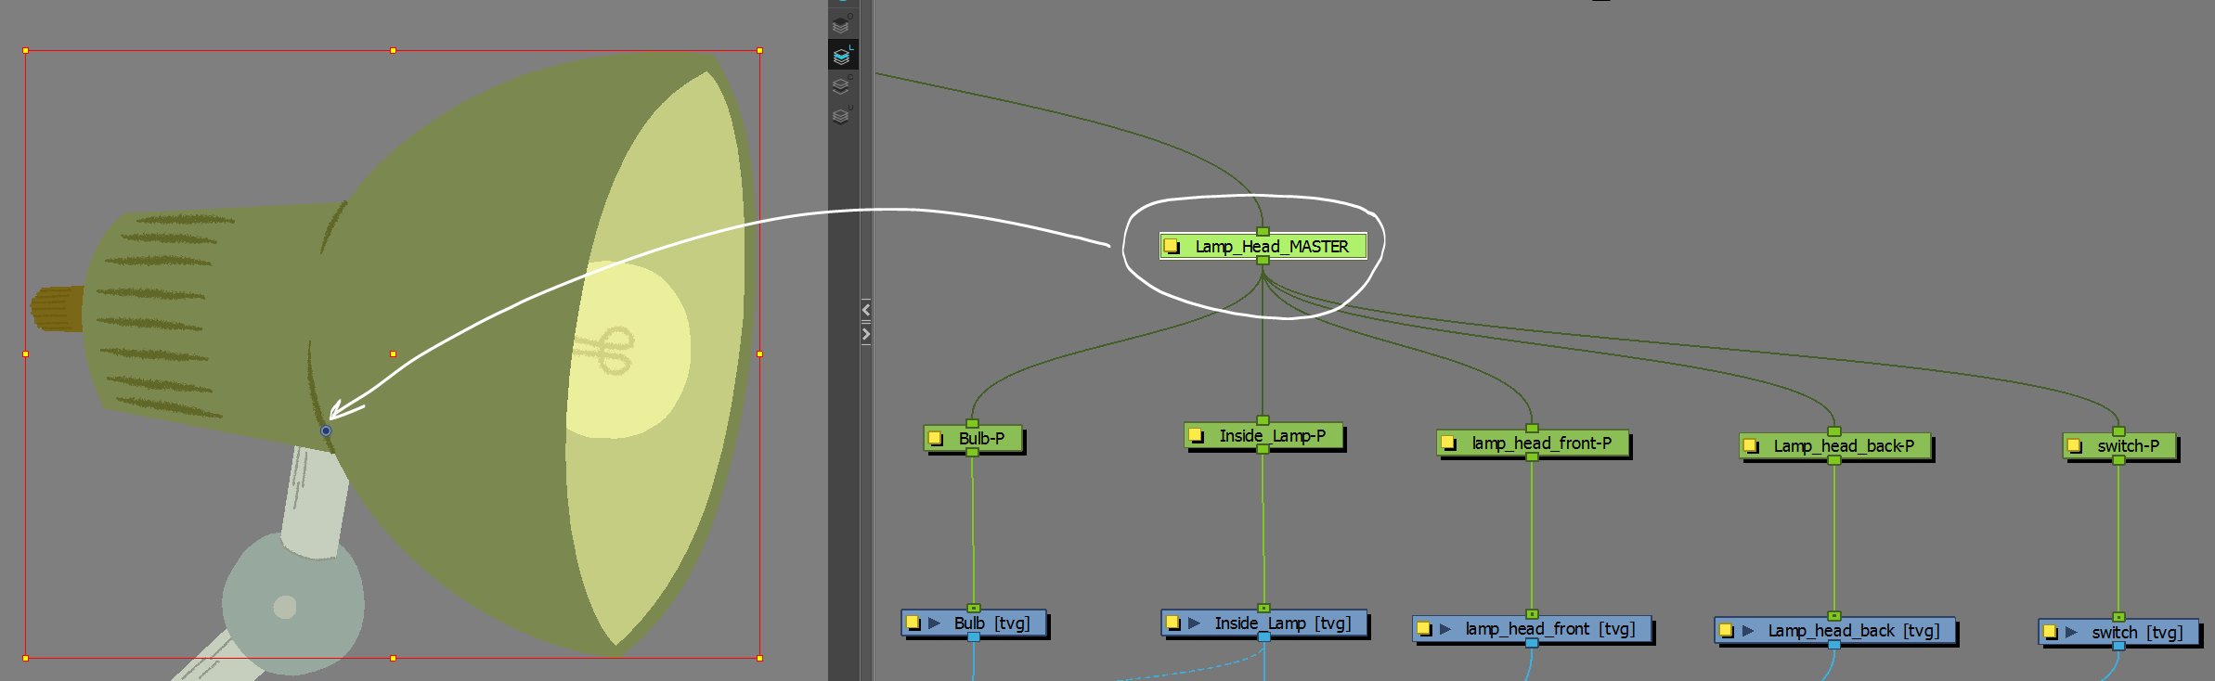

- The next master pegs will be setup with copy and paste information from the Base level pegs.
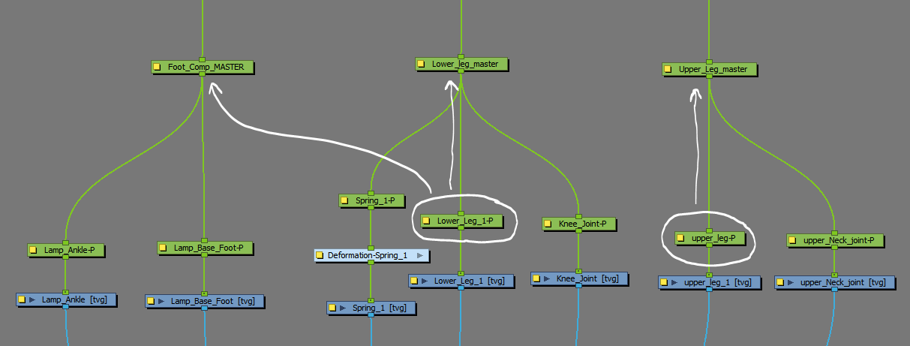

Notice that the Lower leg will share the same pivot information upwards to two master pegs. The foot and lower leg both rotate at the same logical position in the design.
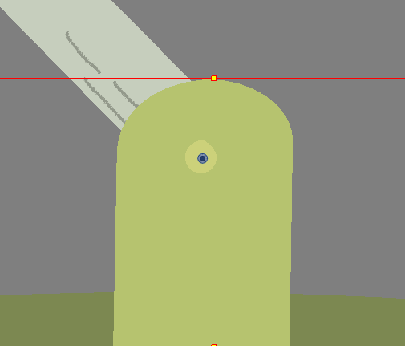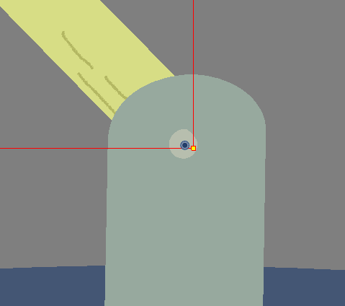

Positioning Master + Comp Pegs:
Next you’ll want to position the final upper Master+ comp pegs, these final pegs will group the lesser ones into a workable Articulation similar to what an arm has.
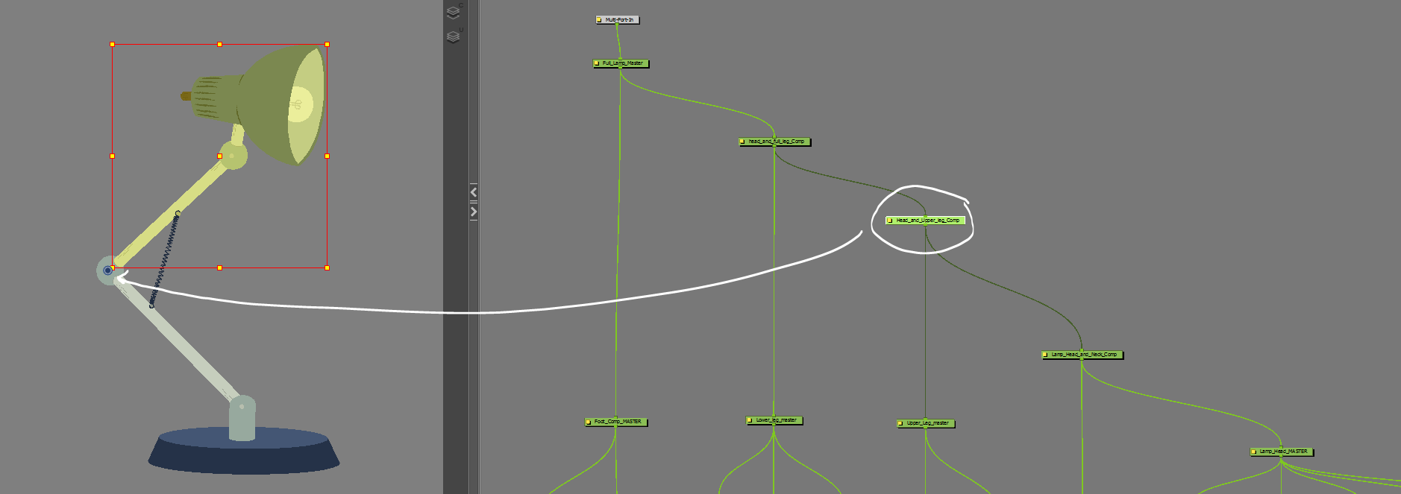

You’ll want to follow the logical rotation points to make sure that they are copy and pasted upwards to the next parent peg.

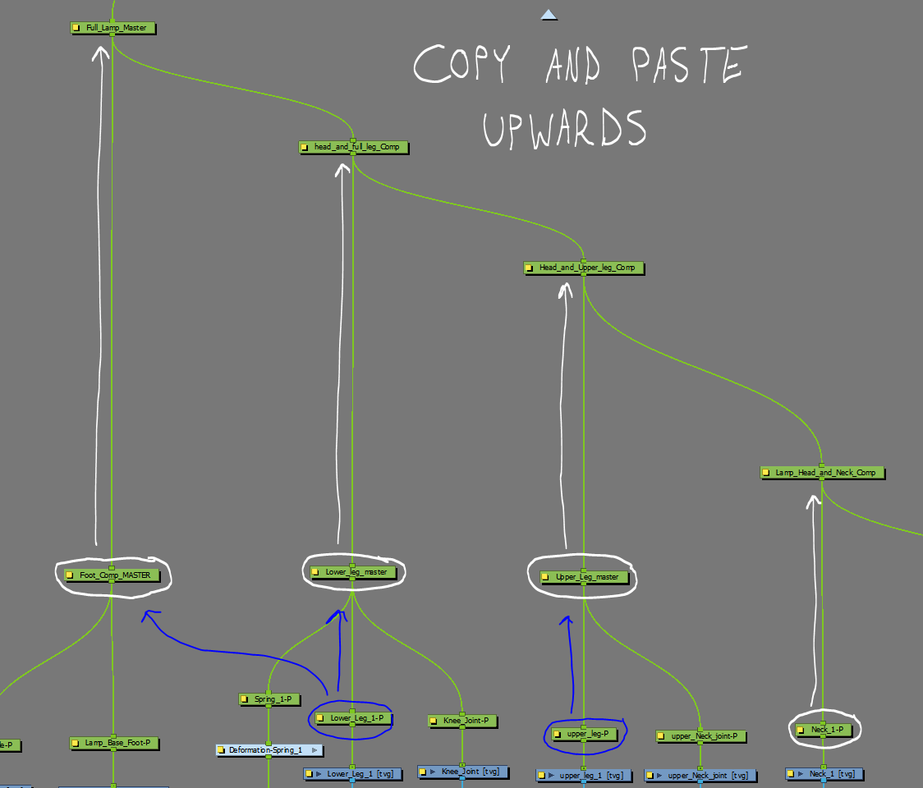

Stress testing the build:
The final step once the rigging of the parent pegs are complete is to stress test the rig to make sure that the joints are working of it are working ok.

- Start out by selecting the Light bulb. Then hit “B” to move up the hierarchy to the “Lamp_Head_MASTER”. Check the pivots on the way.
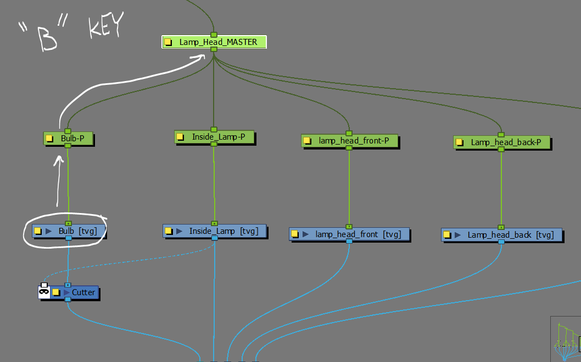

- When you get to the “Lamp_Head_MASTER” rotate it back and forth to see it’s range of motion and make sure there artwork of the neck extends enough.
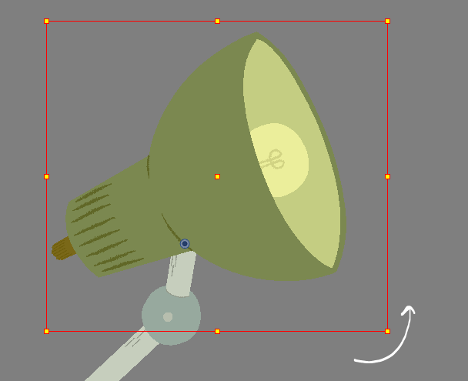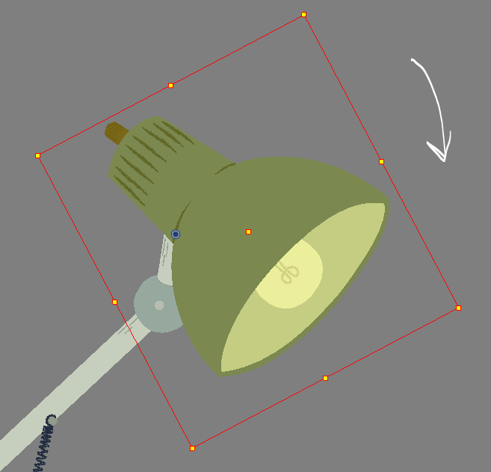

- Once you find it satisfactory hit “CTRL+Z” to return it to its default position.

- Continue up the hierarchy to the next parent pegs and stop to check the range of motion throughout. Push them as far as they can go.
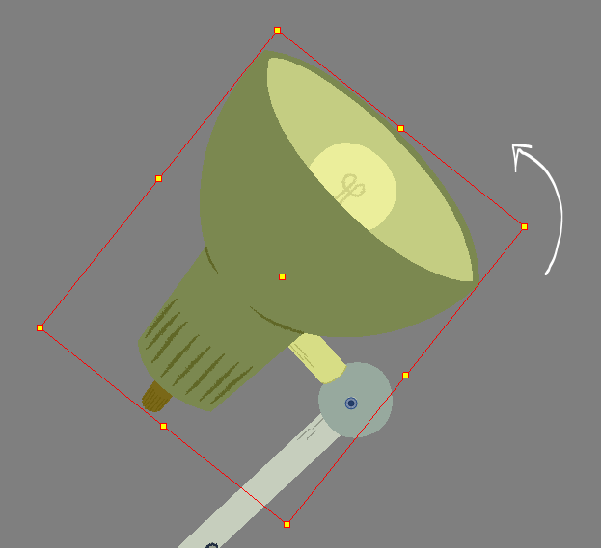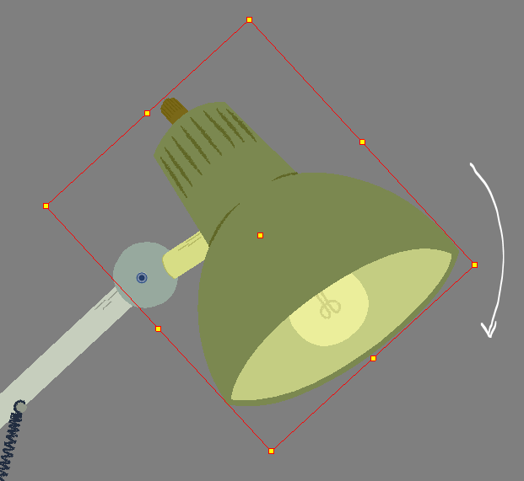
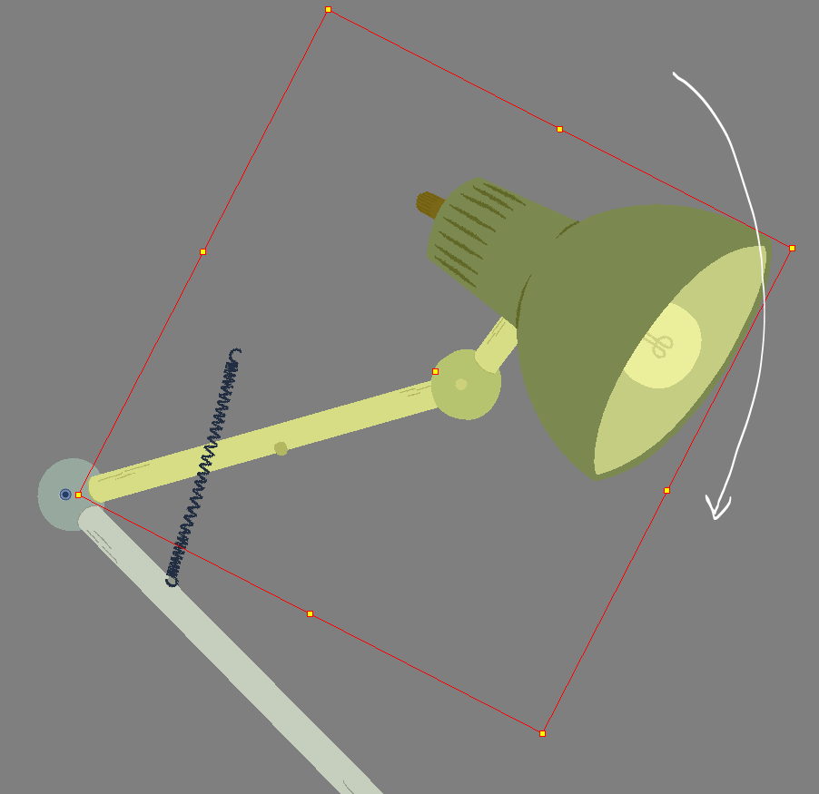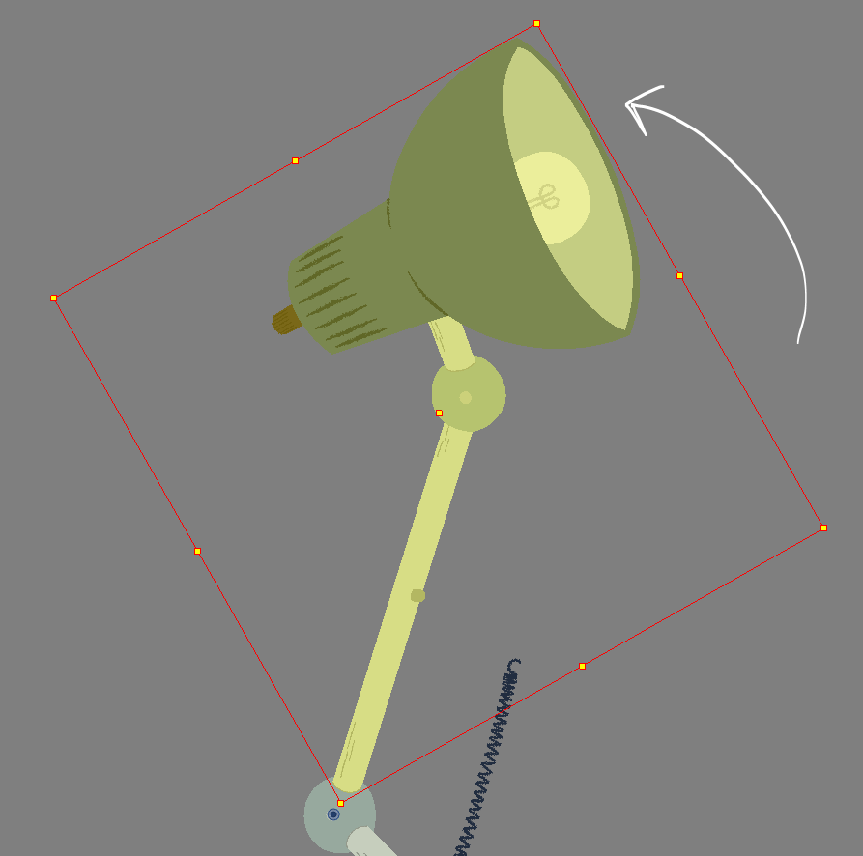
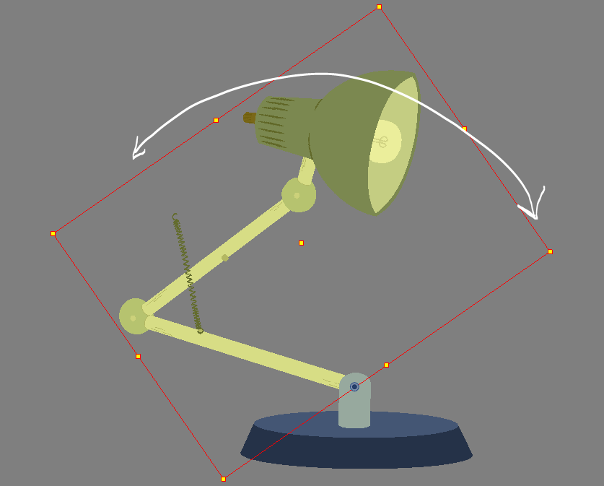
You might find some spots in your builds where the arm come to a collision point. Make note of where it is and see if it’s possible to safely “BREAK” the rig when animating that section.
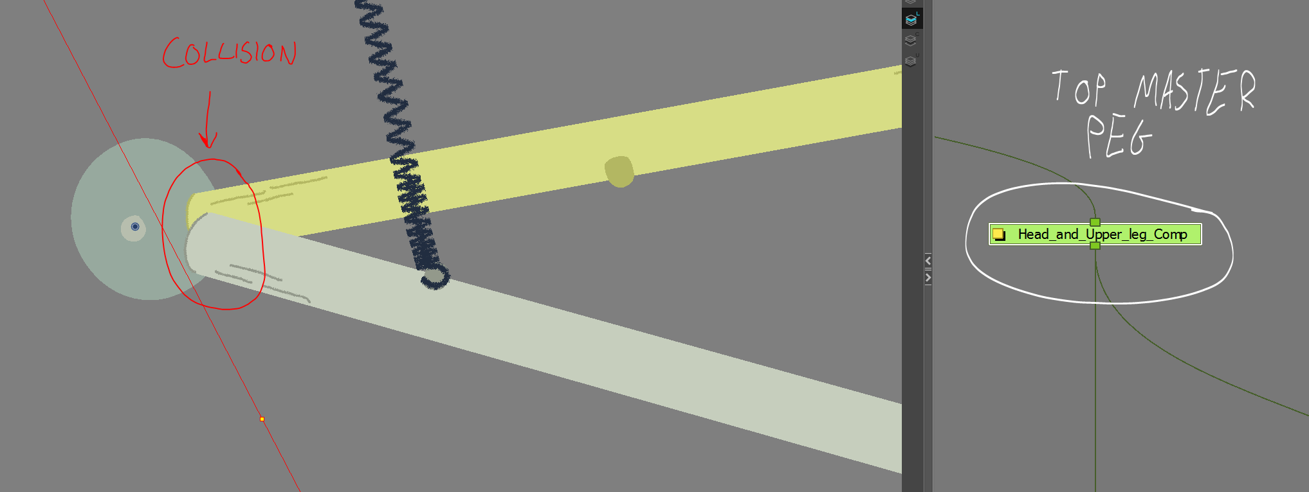

If it’s a collision at a top master peg you can shift the position a little bit safely for this pose without breaking the rig. Just make sure that if the next pose allows in animation it goes back to the default position.
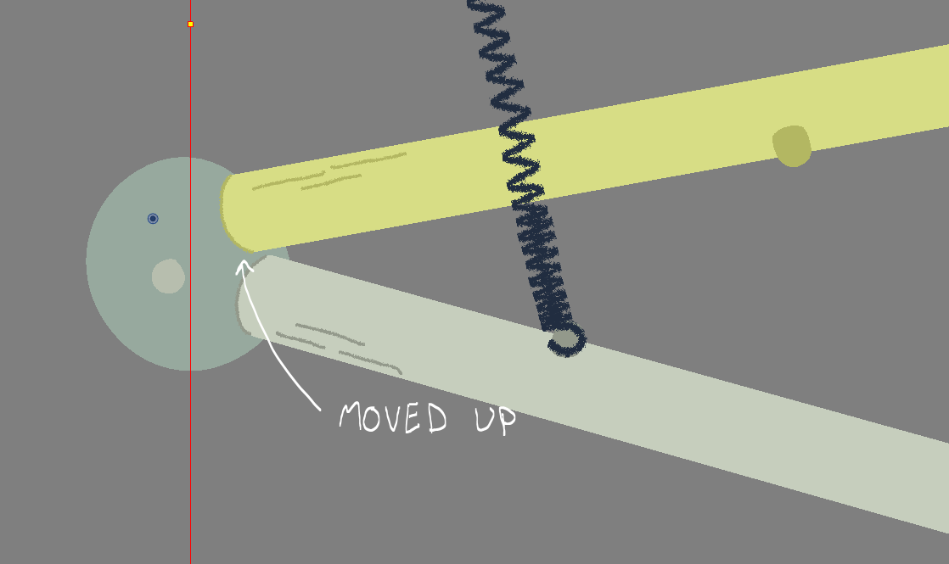

- Do one final pass of selecting each Base Level peg to make sure the pivot points are in a good location.

