Unit 2 Class 4 Reference - Creating the Lamp build artwork:

This reference material covers the following topics:

- Creating the Scene
- Vector edge Artwork
- Editing with the Contour editor
- Using and removing pencil lines to build shapes

This reference material covers how to start building the Lamp build by adding in the artwork to the empty Lamp rig. The Lamp build is a simple articulation like the arm build but with an added “foot” and “head” in the rig.
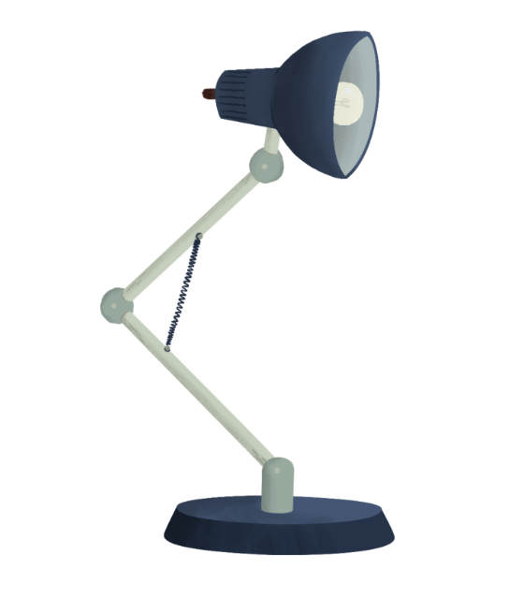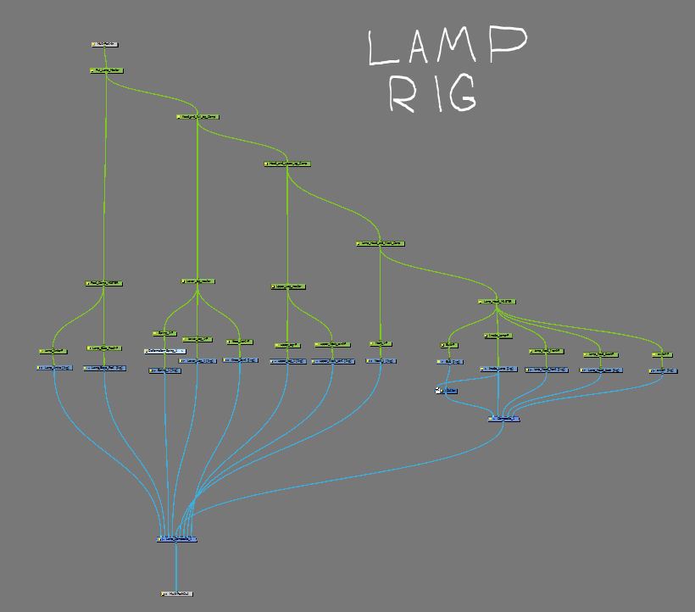

The lamp build (similar to the Pixar lamp Luxo) will give students an advanced articulation to practice new build methods, as well as practice new animation principles with a cutout build.
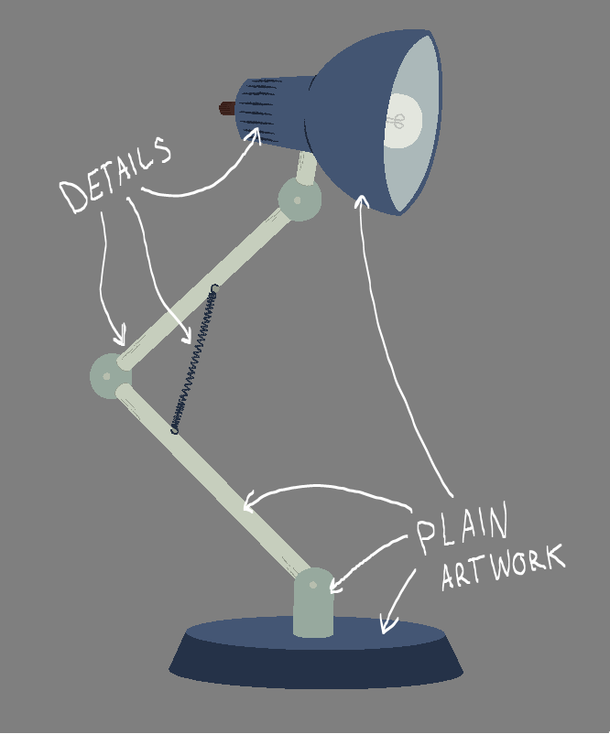

- For this class you will create the plain artwork layers only, details will come later.

Creating the Scene:
Start out by creating a new scene called “Lamp_Build_1”

- When the scene opens up go to your library window and find “(your name) temp library” find the “Lamp Student Package_v1” you put into your desktop Temp Library folder.
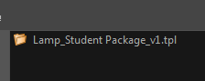
- Bring it into the Node view and plug in the nodes to the composite bar like so.
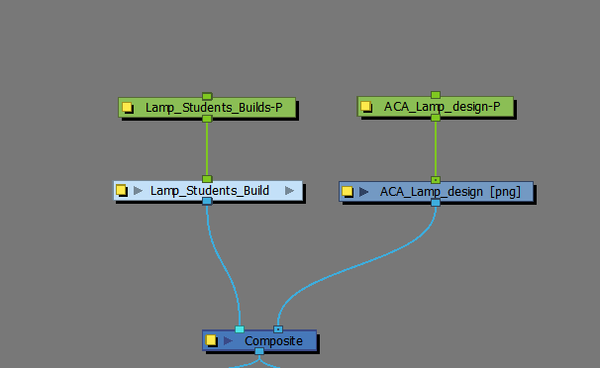

- You should notice the Lamp design appears on frame 1. It might be a little blurry so use the Bitmap image tool bar tool to make the image clear.
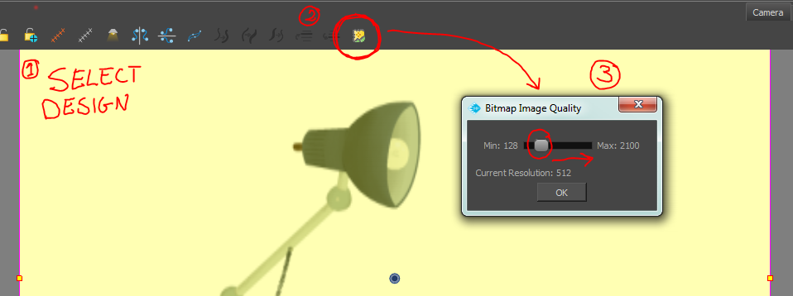

Vector edge Artwork:
The Lamp design doesn’t have any edges to the artwork so the finished artwork will just have a vector line edge to them. Open the group to see the empty rig.
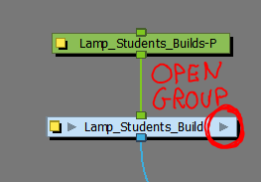

- Find the “Lamp_Head_MASTER” Peg. The nodes below it are filled in first.
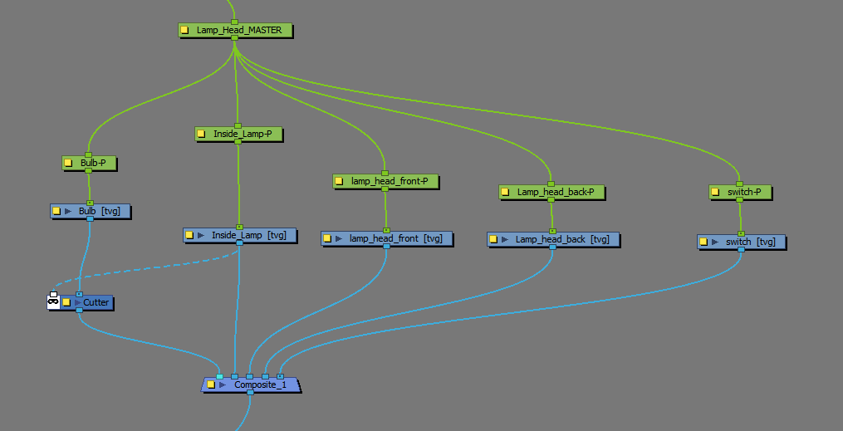

- Start with the “Lamp_head_front” use the Stroke tool to create the outline of the head on the Line Art layer.
- All of the colours you will need to fill in the lamp are in the colour palette “Lamp_1”

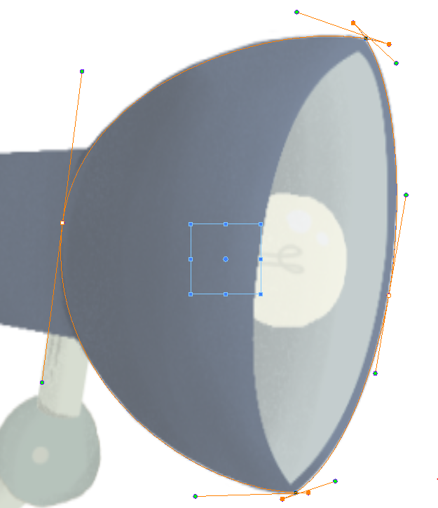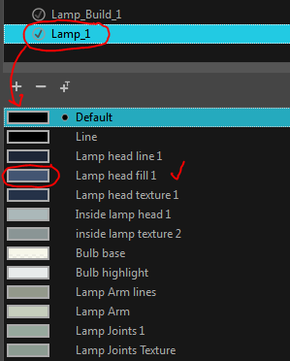

- Outline the other layers of the head with the stroke tool in their corresponding node layers.
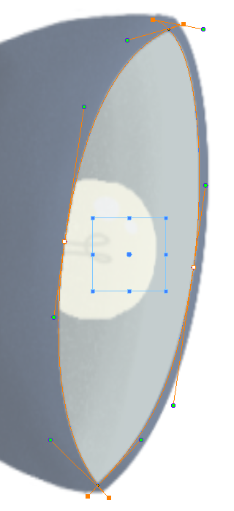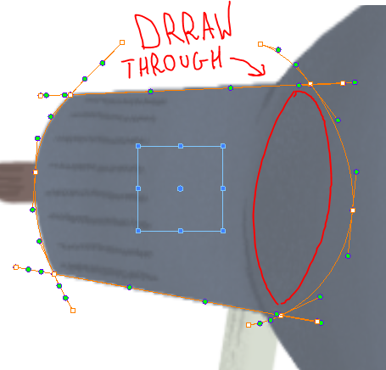

Make sure to Draw through the objects so they have volume and they are not getting matching edges.

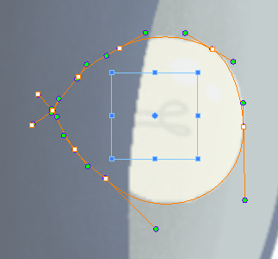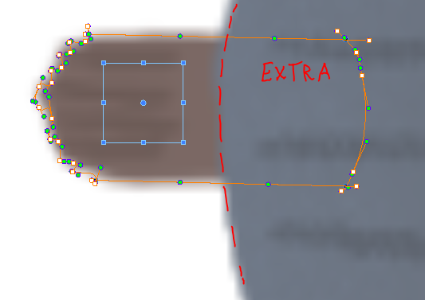

The light bulb node is set up with a inverted cutter to hide the extra bit of bulb.

- Once the outlines are finished fill them in with their corresponding colour swatches.
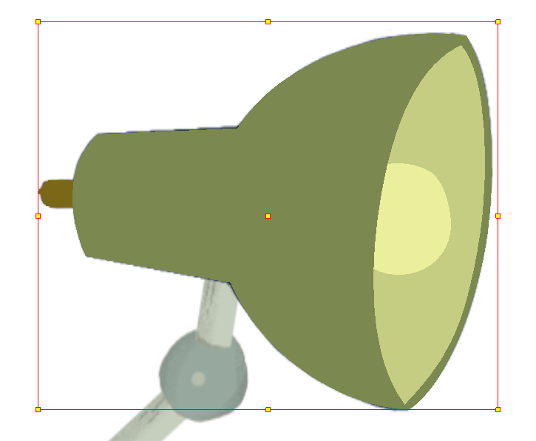

Editing with the Contour editor:
Because the Pieces of the lamp have no outer pencil line, you’ll want to make sure that the edges fit perfectly to the design.

- Use the contour editor to clean up the artwork edges. Remember to remove the Extra Stroke lines after the artwork has been finished.
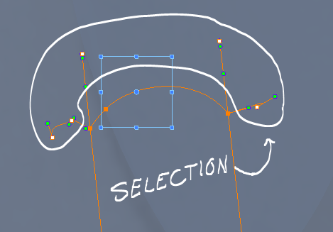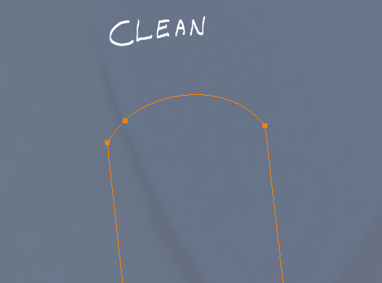

- Keep the Lines as simple as possible when you are creating the curves, lines should be made up of limited points and the bézier handles pulled out to get the shapes you want.
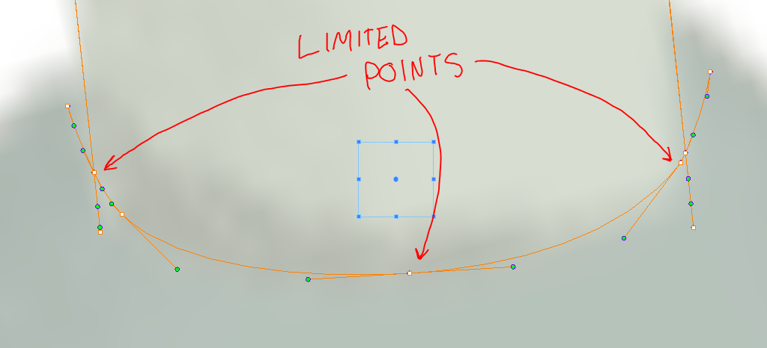

- Make sure to extend the artwork for layers underneath each other. They might need more so when the parts are in motion they have enough to logically move.
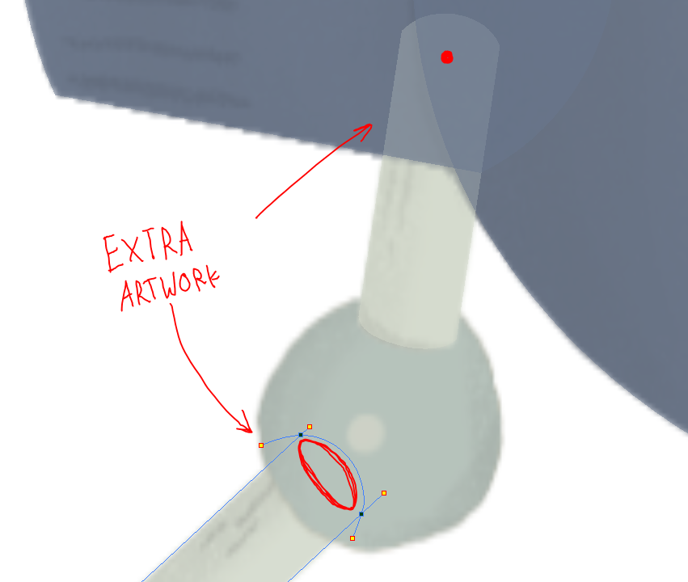

Go through the build and complete the rest of the artwork on the line art layers.

Using and removing pencil lines to build shapes:
For some shapes like circles or ellipses it might be difficult to draw out or shape out the Stroke line. For example, the foot of the lamp.
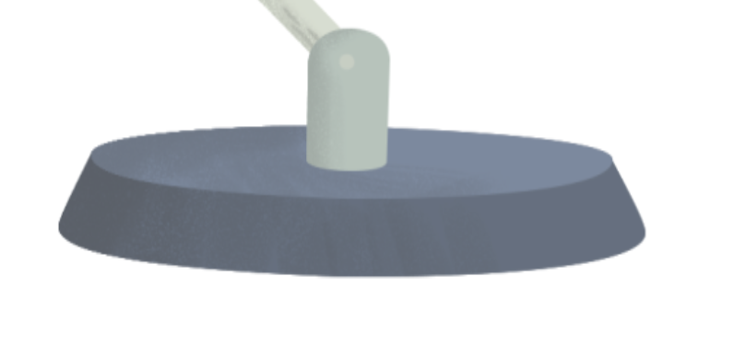
- Use the Ellipse tool to match the round section of the foot top, you may need to use the contour tool to adjust the curve a little.
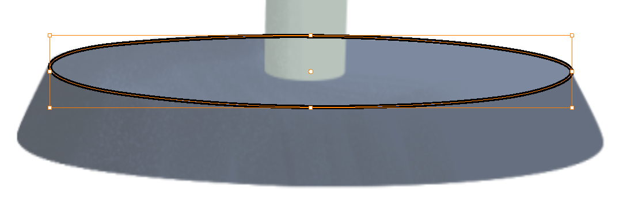

- Once the top part is drawn out, copy and paste it to the lower base of the foot, scale it to match the size of the base.
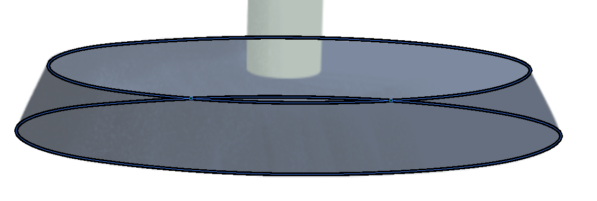

- Finish off the sides and get the lines closed off flush.
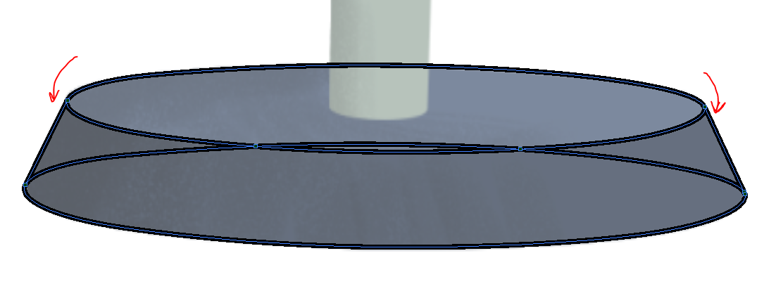
- Clean up the middle lines only keep the ones that you need.
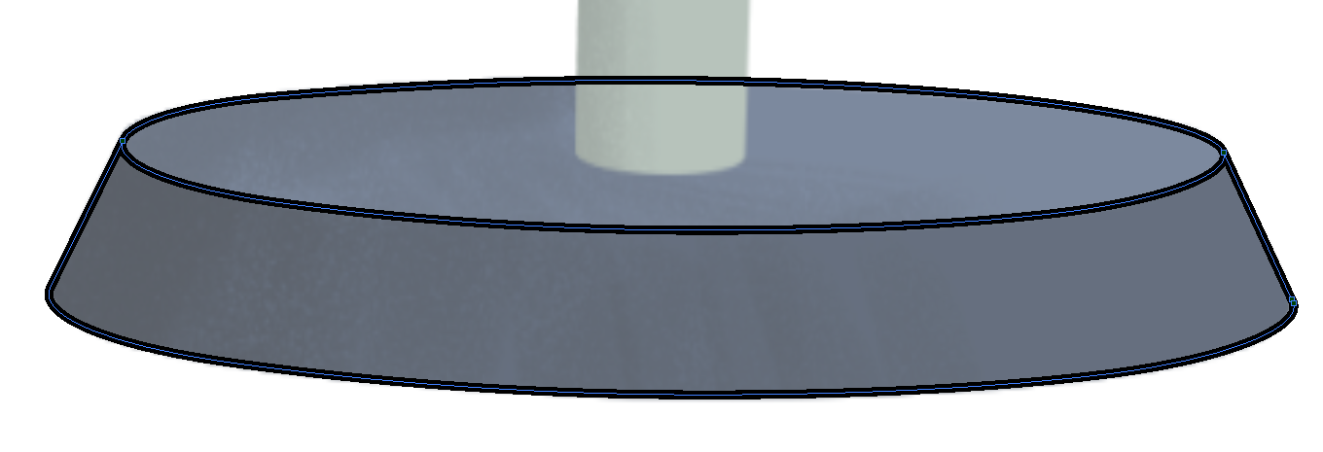
- Now fill in the Sections with the proper colours.
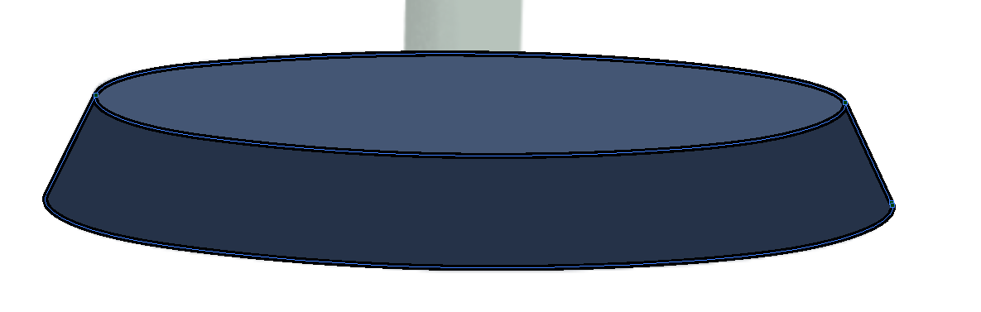
- The final step is to remove the Pencil Lines. Select everything, Hold down “SHIFT” and click the two fills to deselect them. Then hit delete to remove just the pencil lines.

