Unit 1 Class 8 Lesson - Detailed Walkthrough:
Toonboom Harmony, hand drawn concepts and the bouncing ball
“Bouncing our way down”

This class covers the following topics:

- Setting up the hand drawn scene
- Working within a hand drawn workflow
- Blocking out a scene
- Inbetweening keys
- Cleaning up animation
- Stretch goals and planning for next assignment

Outcomes: Students will have an applied understanding of hand drawn concepts, timing and spacing, and setup of a digital hand drawn pipeline.

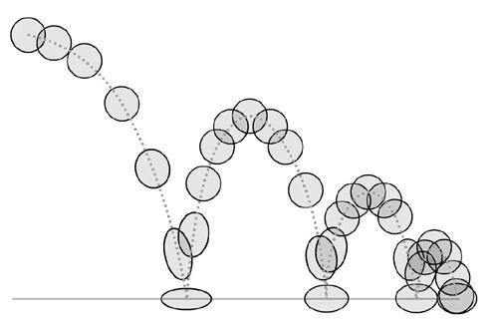

Let’s start:
Load up Harmony and create a new scene to work in. Call this one “BBall_Handdrawn_1” and save it into the Harmony scenes folder on the desktop.

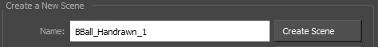

Setting up the hand drawn scene:

Animating a hand drawn bouncing ball is very similar to the cutout bouncing ball in that the same concepts of timing and spacing apply to both. Setting up the sc however will be slightly different as the approach to hand drawn animation will be different.
For this assignment you will be bouncing the ball through the frame instead of just in place. Set the scene length to 130 frames.

- Start by creating new drawing layers for the scene. Give them named pegs.
- “Bouncing_Ball_1”
- “Chart_lines_1”
- “Rough_Layout_1”
- “BG_line_1”

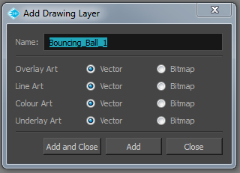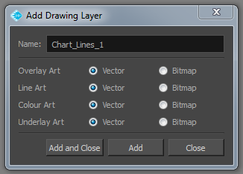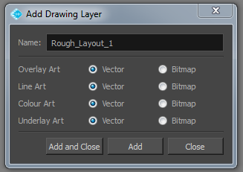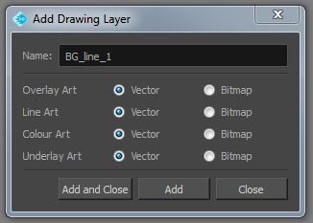

- Plug the nodes into the composite bar in order.
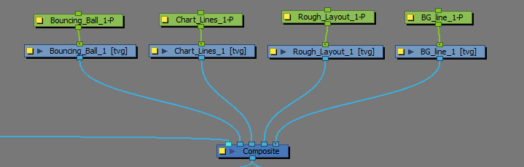

- Create a new colour palette in the colour tab. Name it “BBall_HD_1”
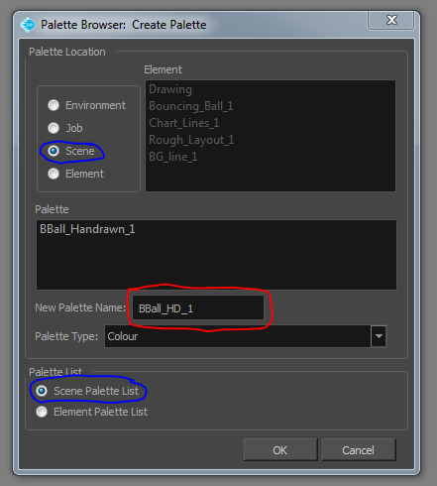
- Create 7 new colour swatches to work with.
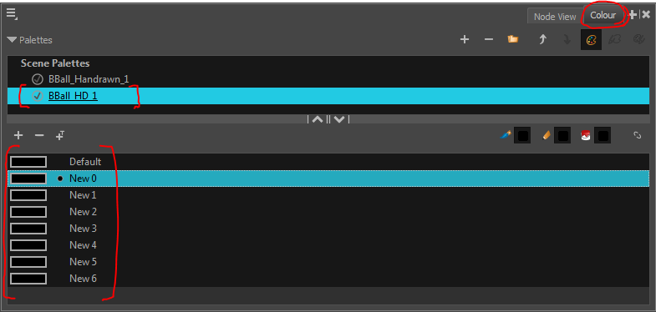

- You will be using this palette for both your roughs and clean colours. Name them and change their colours to match.
- “Clean line 1”
- “Clean Fill 1”
- “Keys”
- “Breakdowns”
- “Inbetweens 1”
- “Inbetweens 2”
- “BG line 1”

- In the Drawing node layer “BG_line_1” Handdraw out a horizon line/Background in harmony. Extend it to the end of the scene.
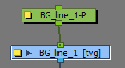

- Bring in a colour card from the node library to place behind the nodes.
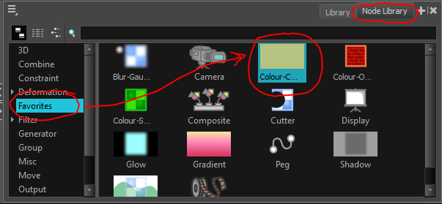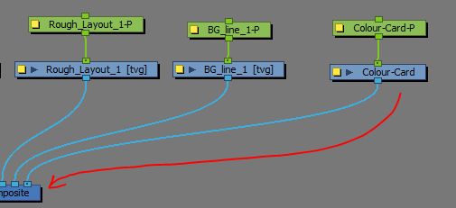

- or import a background or image from elsewhere to use. Extend it to the end of the scene.
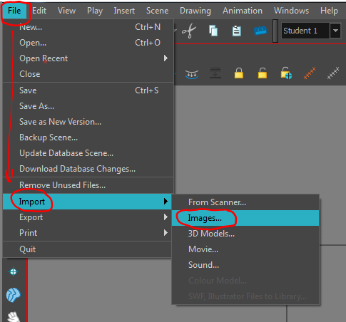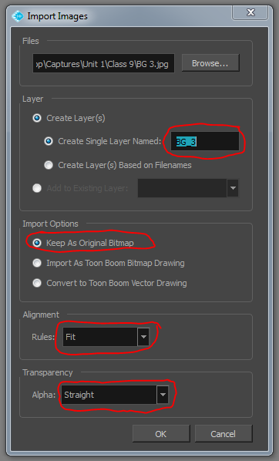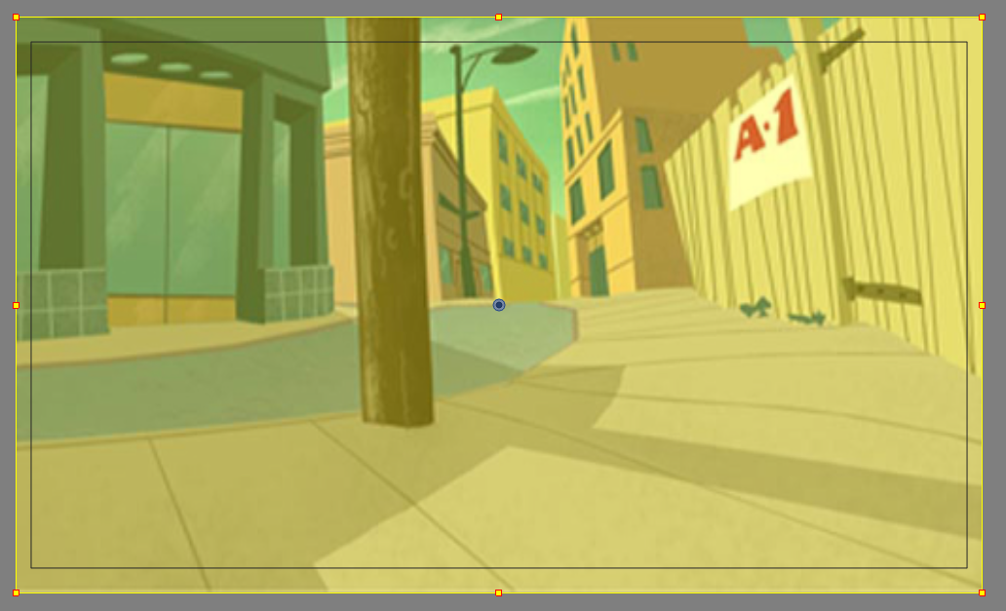
- Setup the Brush size you will be using for roughs and pencil sizes you will be using for clean animation.
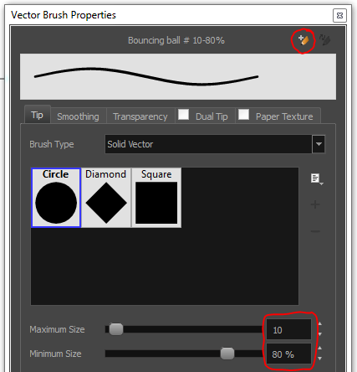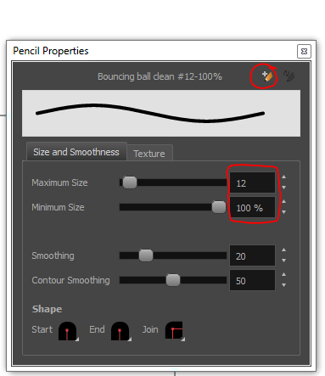

- Before you start to draw out your bouncing ball you will need to create a layout of the path of action that you want the ball to follow. In “Rough_Layout_1” draw out your line of action. Extend it to the end of the scene.
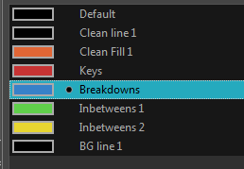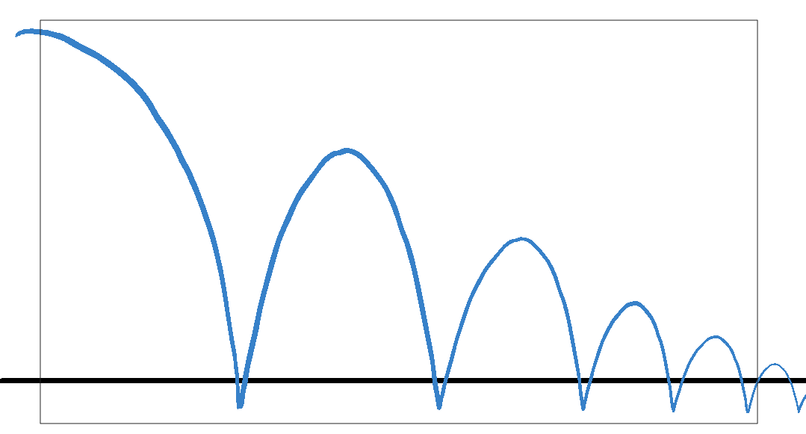

- Your node view should look something like this.
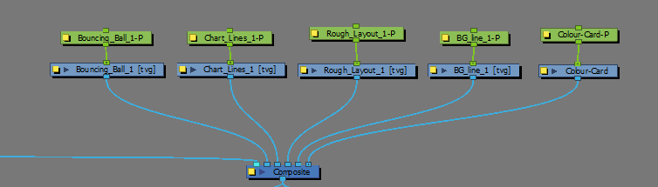

Now that you are all setup it’s time to start fleshing out the bouncing ball.

Working within a hand drawn workflow:

When working in a hand drawn workflow it’s especially important to understand the concept of keys, breakdowns, and inbetweens. While similar in cutout animation, much of the work in the break downs and inbetweens is approached differently. To recap.

Keys:

Keys are the major storytelling drawings in animation, and each key drawing carries important information about how a character carries out a particular action and the next action after that. Keys are always drawn out first.

In a bouncing ball the keys are the contact pose and the height of the arcs. These are storytelling poses as they show the balls extreme contrasting poses before changing direction. Without these it would be impossible to tell what the action is supposed to be.

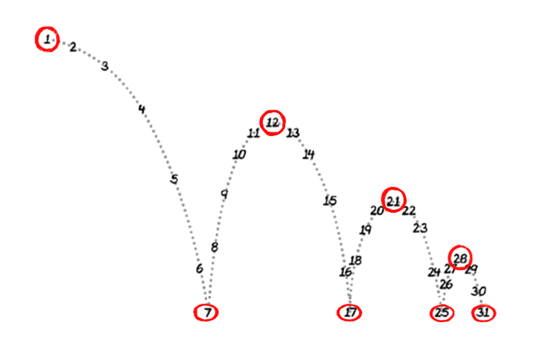
In this case the red circled numbers are the keys.

Breakdowns:

Breakdowns drawings help to flesh out the storytelling of an action by directing how the transition between key drawings is performed. More complex breakdowns could sometimes be considered key information. It’s up to the animator, and the action being done to determine how much extra information is needed in a breakdown.

In a bouncing ball the breakdowns are the drawings that help to show how the ball is transitioning into and out of the contact pose, as there is a forceful change of direction involved.

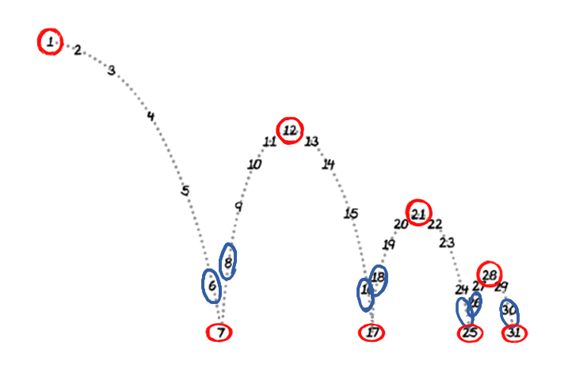

The breaks down here are labeled in blue.

Inbetweens:

Inbetweens are the remainder drawings of an action that flesh out the fullness and smoothness. They establish our easing and which Keys will have more overlapping action to them. In hand drawn animation inbetweens are typically halved

In the bouncing ball, the inbetweens determine the path of the action, and how much hang time there is at the top of each bounce.

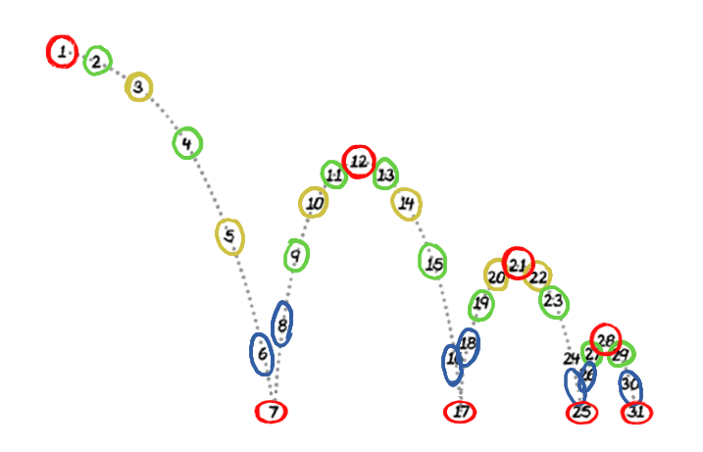

Here the inbetweens alternate between Green and yellow.

Drawing out the roughs:

Using the keys, breakdowns, and inbetween colours from your colour palette will make the whole process easier to inbetween. Since pegs won’t be used in the process leave the pivot point in the default position and make sure to drawn in your squash and stretch in the first pass. Keep it loose through the first pass, just think about position and volumes, the lines don't need to be clean. Draw in your “Bouncing_Ball_1” layer

- Rough out the Keys of the bouncing ball along your rough layout. Draw the keys one after each other on the timeline using the Red Key colour.
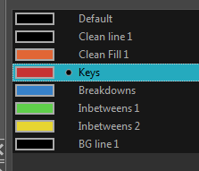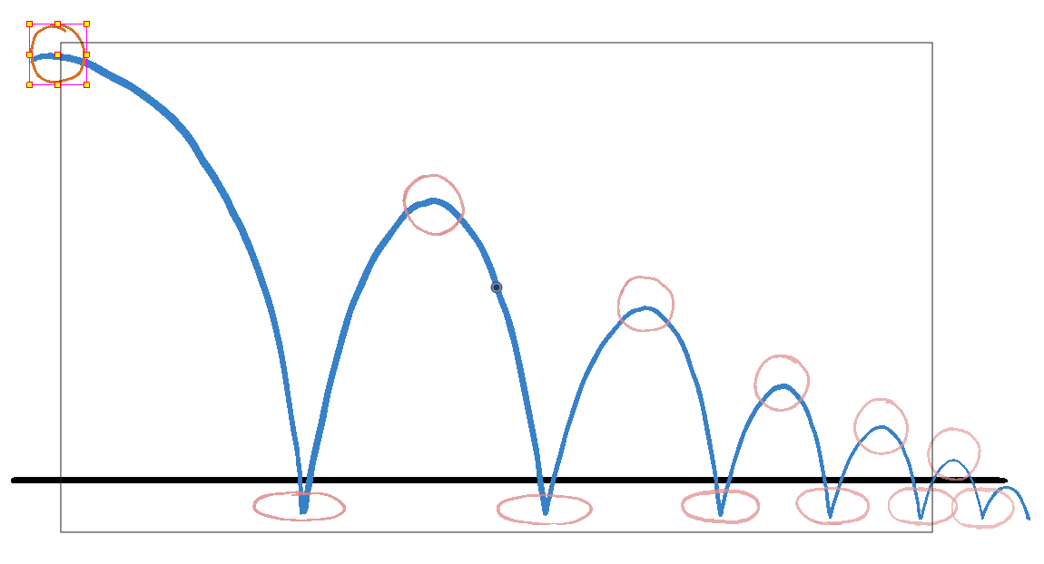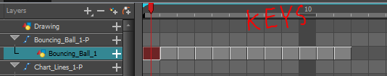

The placement of the keys on the timeline with be adjusted with shift selections throughout the process.

- Shift over the keys to be on 2’s to make room for the Breakdowns. In the new spaces create new drawings.
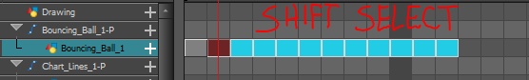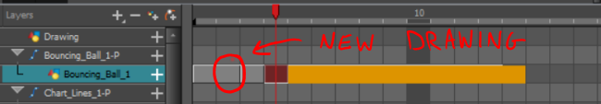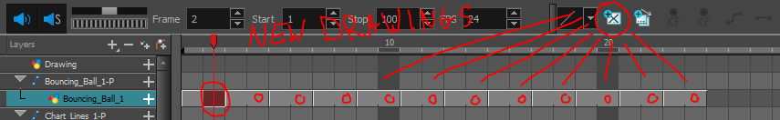

- Draw in the Breakdowns using the Blue Breakdown colour in the new drawings.
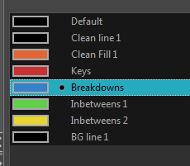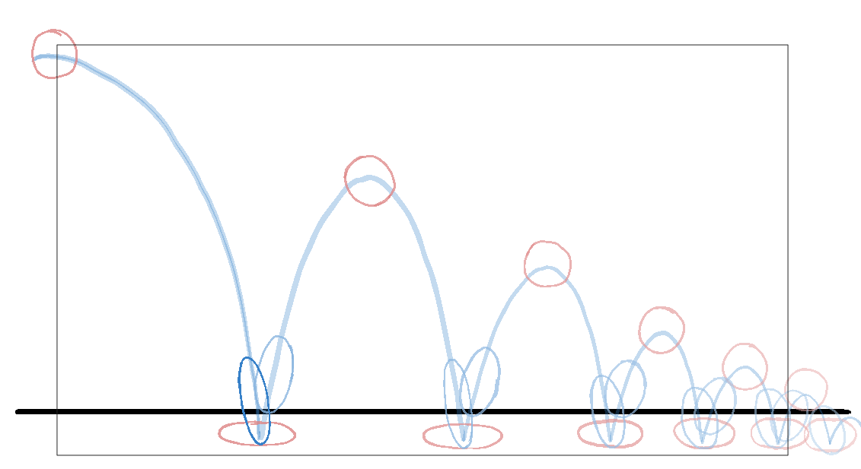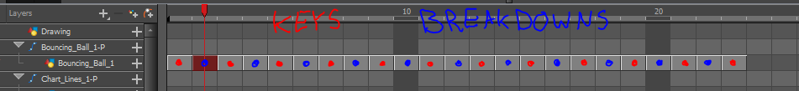

Blocking out a scene:
Now that the main information of the bouncing ball is complete, the next step is to block out the timing and get the charts lines in.

- Start by moving your keys and breakdowns along the timeline to roughly gauge the timing of the bouncing. Play through the sene and see how the timing of the drawings feels.
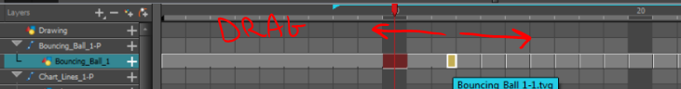

- Reposition your Keys and breakdowns with 2’s in mind for your inbetweens.
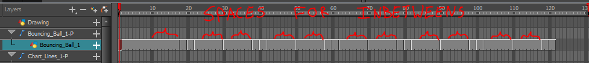

- Chart out the actions from key to key to include your inbetweens. Keep in mind that your break downs will need to be included.
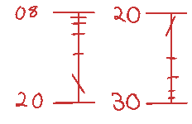
Since this will be hand drawn they should be spaced in direct halves.

Inbetweening keys:

When drawing out your inbetweens use the onion skin to find the points of the ball to track and draw your inbetween lines through the middle of the tracking points.
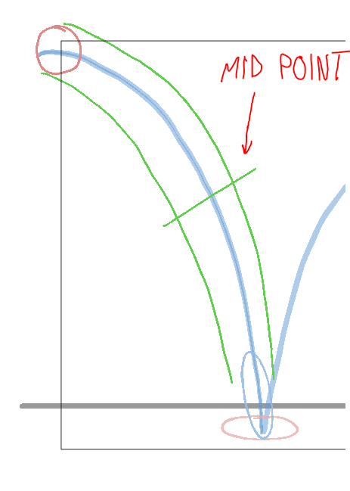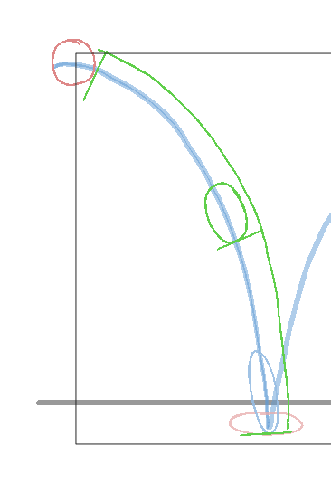

- Alternate the rough Green and Yellow colours for the inbetweens to avoid confusion with the onion skin.
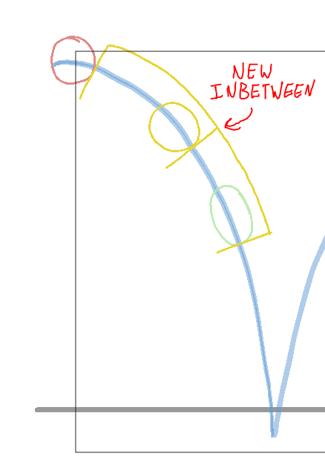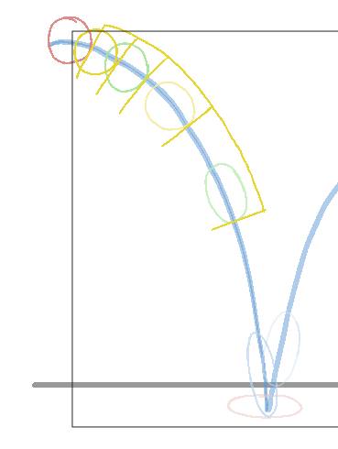

If it does become confusing limit the handles of the onion skin to two drawings.

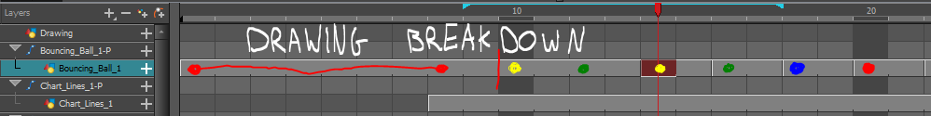
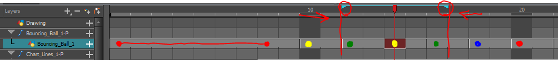

Cleaning up animation:

When the roughs are completed you will have to do a final clean up pass on top of the roughs to give the best looking animation with a consistent line.
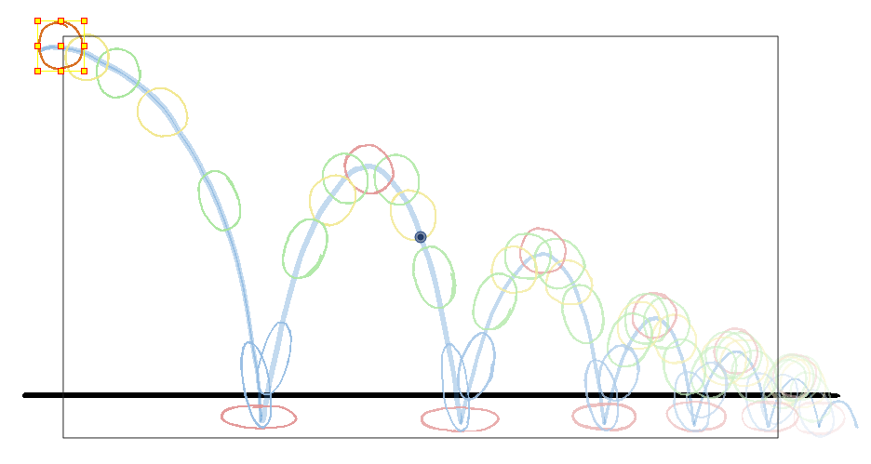

- Switch from the Line art layer to the Overlay layer in the Drawing nodes layers.
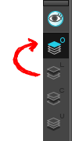

- On your first frame of the drawn ball Switch to the “Clean Line 1” colour. And then switch to your pencil tool.
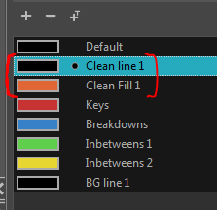

- Trace over your roughs keeping the volume of the ball in mind throughout. You may need to make some corrections.
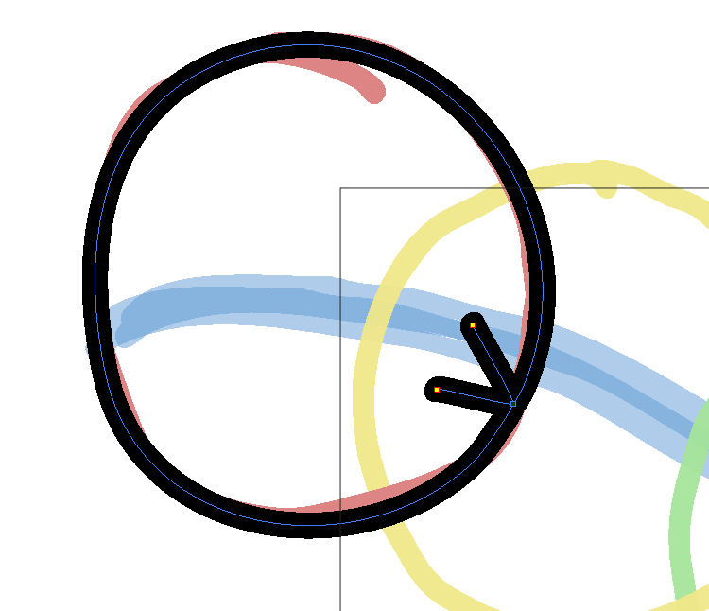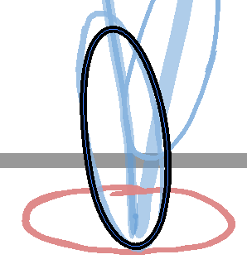

Once the clean lines have been drawn in on the Overlay layer you need to colour in all of the Drawings.

- Switch to the Paint Un-painted tool and select the “Clean FIll 1” colour.
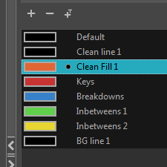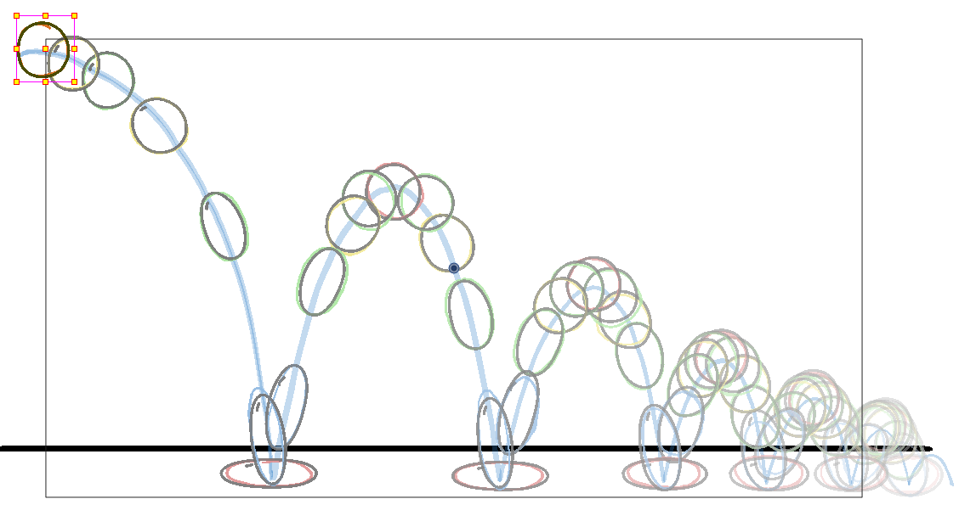

- In the tool properties window of the Paint Un-painted tool select the Option “Apply to multiple Drawings”
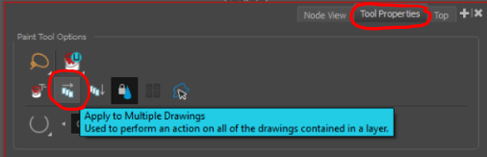

This option will allow you to paint in the ball in all of the drawings across the timeline.

- Using the Paint Un-painted tool lasso the entire area where the bouncing balls action is occurring.
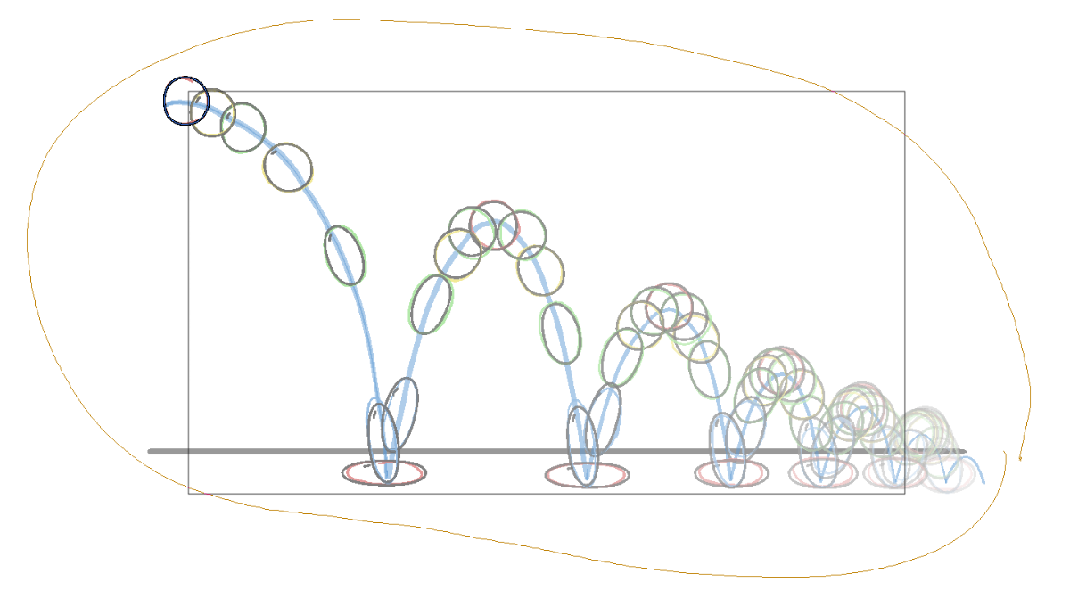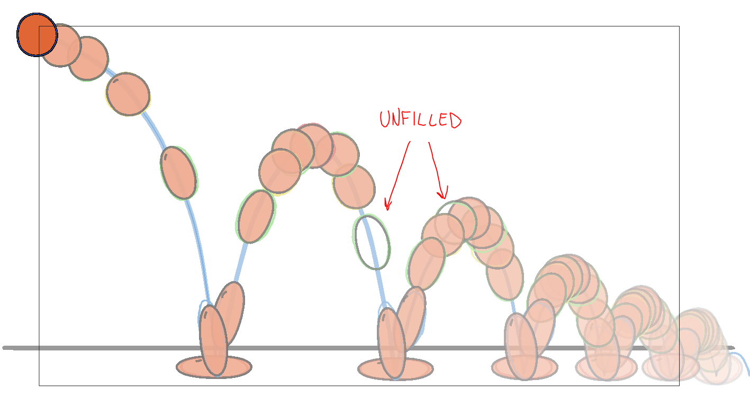

- A simple scrub through should show that most if not all of the drawings have been filled in. if any are missing their fill go through and fill them in individually.

A stretch goal is to fill the ball in with a radial gradient fill and adjust the inside gradient of the ball through out to match the position of the lighting.

- Gradient fills will need to be adjusted per frame.
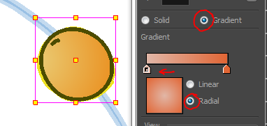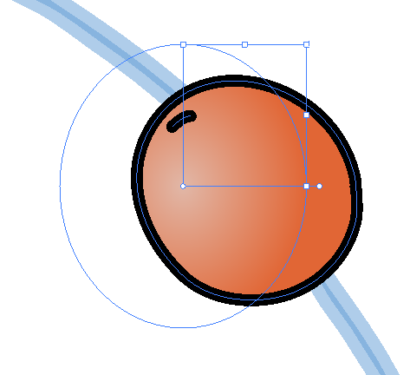

- Go into the properties of the “Bouncing_Ball_1” and turn off the visibility of the Line Art layer.
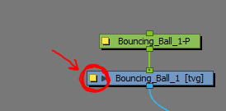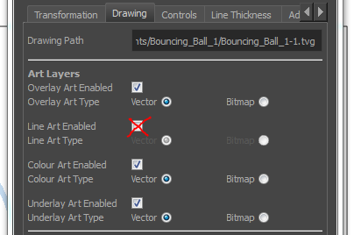

- The last step is the Disable the Rough layout.
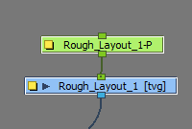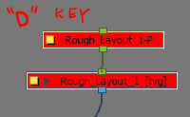

If everything is looking satisfactory, setup the render to export a movie file for handing in.

- Set the sc to render a quicktime movie in the Write Node properties window. Choose the render folder on your desktop.

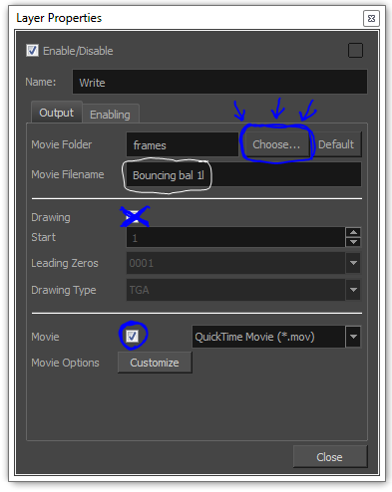

Stretch goals and planning for next assignment:

If you finish early or wish to push yourself further try doing some stretch goals.

- A new background for the current bouncing ball.
- A bouncing ball coming towards the camera in 3/4 perspective.
- Plan for the Unit 1 Final assignment.

Final assignment:

The Unit 1 final assignment will be to make an abstract form animation based on the tools and techniques you have learned so far in the final class.

Examples:

https://www.youtube.com/watch?v=eoJ702pM4Kc

https://www.youtube.com/watch?v=ltTWu3kndM0

https://www.youtube.com/watch?v=d24xrC_XQgQ
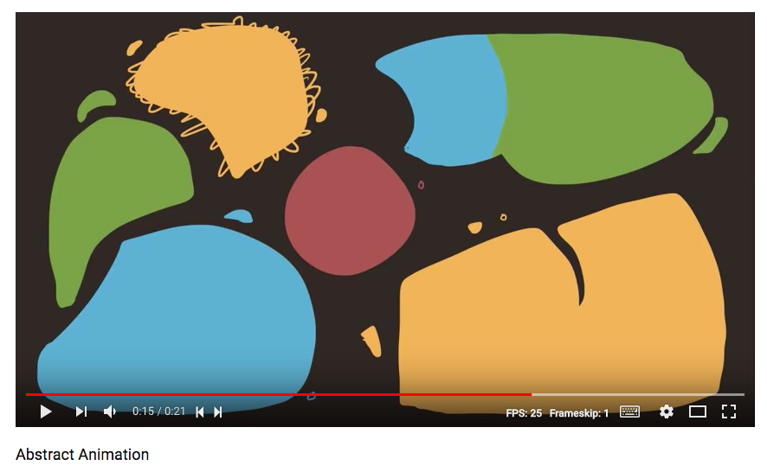

- If it helps create some thumbnails for ideas and concepts of what you might like to do. Thumbnails allow you to explore options and ideas in small rough 1 inch by 2 inch panels in a non-committal way.
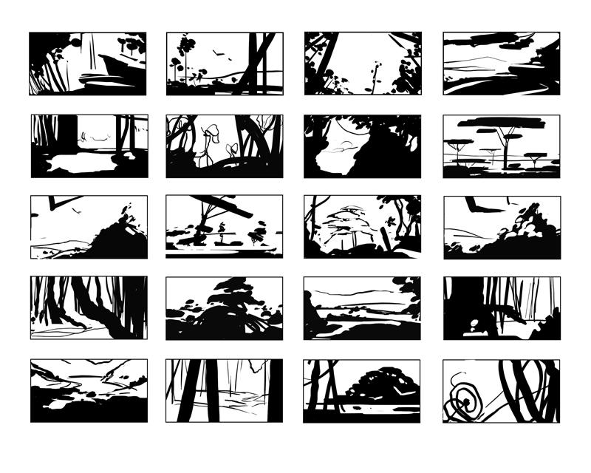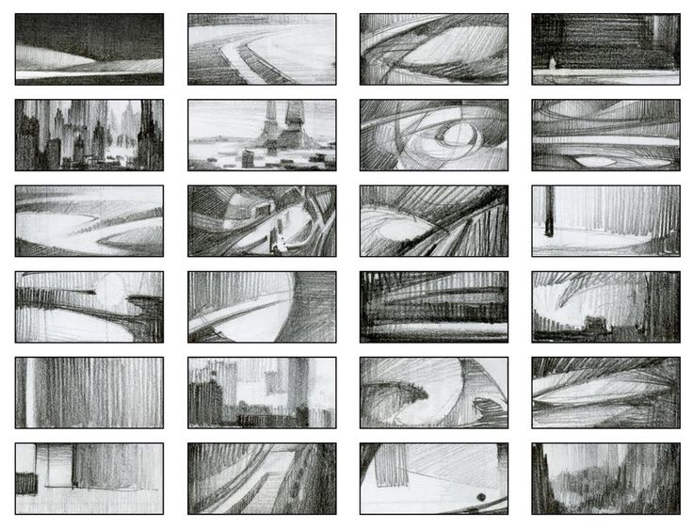

Push for abstraction, textures and timing. Based on what you have learned so far with the program see what intrigues you the most.

- Look online for reference videos and images.

- Will your animation have sounds and music involved?

- Think about what you want to say or not say with your piece.

